TECHNICAL DATA SHEET
NOZZLES

Photo | Description | QTY | Hose con. | Minimum  /GPM | Pipe Diameter | Dimensions | Weight | Rear Jets | Front Jets | Radial Jets | Tier
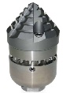 | Pipe wolf nozzle 3D | 4 | 1 ¼ “ | 80 | 8”-24” | 7.48”X3.74” | 11.9lbs. | 6 | 3 |  | 3
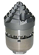 | Pipe wolf nozzle 3D | 4 | 1” | 60 | 6”-15” | 6.29”X2.83” | 5.73lbs. | 6 | 3 |  | 3
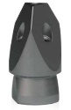 | CHISEL NOZZLE | 4 | 1” | 60 | 8”-20” | 6.29”X2.95” | 5.51lbs. | 6 | 5 | ___ _ | 2
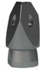 | CHISEL NOZZLE | 4 | 1” | 80 | 8”-15” | 3.74”X2.36” | 1.50lbs. | 8 | 4 | ___ _ | 2
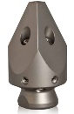 | RADIAL CHISEL NOZZLE | 4 | 1” | 80 | 8”-20” | 6.29”X2.95” | 5.51lbs. | 6 | 5 | 6 | 2
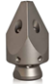 | RADIAL CHISEL NOZZLE | 4 | ¾” | 30 | 6”-12” | 4.13”X2.36” | 2.42lbs. | 6 | 5 | 6 | 2

REDUCER & COLLAR
ENLARGING COLLAR – STAINLESS STEEL
 |  | 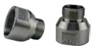 | Quantity
¾” male | → | 1” female | 4

REDUCER – STAINLESS STEEL
 |  | 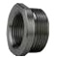 | Quantity
1 ¼ ” male | → | 1” female | 4

Jets spare heads must be included for all nozzles.

