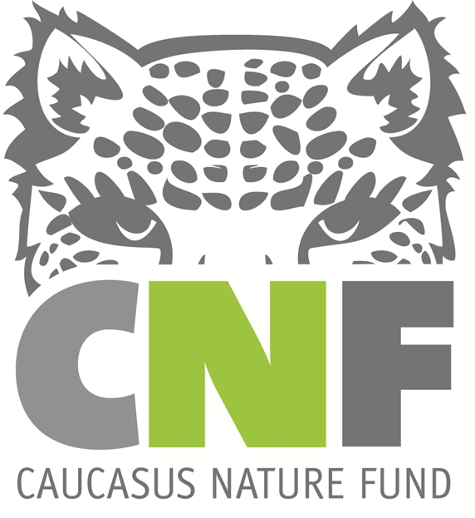

Title: Environmental and Social Due Diligence (ESDD) of Protected Areas of Georgia

Provided by: Caucasus Nature Fund (CNF)
Deadline: 07.06.2023 COB Tbilisi time

The Caucasus Nature Fund (CNF), is a German non-profit organization that supports the protected areas in the South Caucasus countries of Armenia, Azerbaijan and Georgia. The fund provides long-term funding for operating costs and supports improved management and sustainable development of the region's protected areas.

In order to manage environmental and social issues in line with the national laws and regulations in Georgia and in line with the requirements of international Environmental and Social Safeguard Standards, CNF will be implementing an Environmental and Social Management System (ESMS) starting from July 2023.

Under its ESMS commitments, CNF will commission an independent Environmental & Social Due Diligence (ESDD) prior to renewing existing and launching new Grant Agreements with individual protected areas / management units.

CNF is therefore seeking experienced consultants/organizations (citizens of Georgia/registered in Georgia) to complete ESDDs for up to 13 management units across Georgia throughout 2023-2025.

The full Application Package should be sent to recruiting@caucasus-naturefund.org marked as “Protected Area Environmental and Social Due Diligence (ESDD)”
The detailed information about the tender is provided in the attached ToR file.

Note: Only short-listed candidates will be contacted.

