Request for Proposal
P1364 – RMG Copper

Valves

CONTENT
- INTRODUCTION AND PROJECT DESCRIPTION 3
- CLOSING DATE 3
- SUBMISSIONS 4
- PRICING 4
- SCOPE OF DELIVERY 4
- TECHNICAL SPECIFICATION 5
  - VALVES 5
  - CONTROL LOOP 6
- DESIGN INFORMATION 6
  - SITE AND OPERATION CONDITIONS 6
- SUBMISSION REQUEST 7
- ATTACHMENTS TO THIS REQUEST FOR PROPOSAL 7

INTRODUCTION AND PROJECT DESCRIPTION

JSC RMG Auramine is carrying out the detailed engineering of its new Tailings Storage Facility (TSF) and is requesting the proposals for procuring the valves needed within tailings thickening area and long-distance pipeline. The site is located in southern Georgia (Eastern Europe), approximately 80 km southwest from capital Tbilisi, near the town of Bolnisi. Site access will be via paved local roads. Refer to figure 1 for general site location
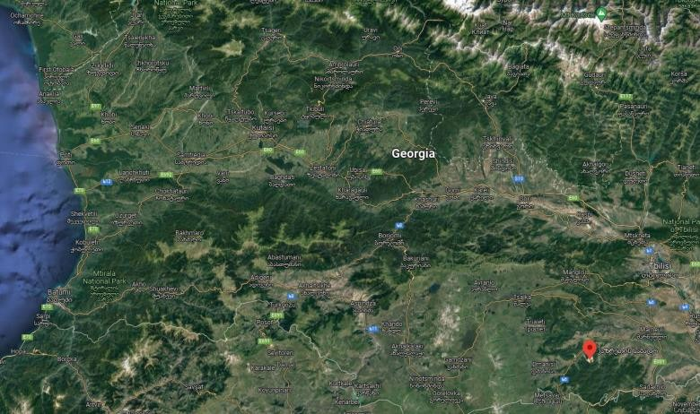

JSC RMG Copper Site Location

Figure 1: JSC RMG Auramine, Site location

The present document covers and provides the minimum requirements and specifications needed for manual valves, on/off valves, control valves and self-acting pressure regulators for tailings thickening and the tailings long-distance transport areas.
All communications with respect to the RFP are to be directed to RMG Auramine by email to the below list of recipients:

Recipient | Position | Contact email
Gvantsa Gvazava | Head of Procurement Group | ggvazava@richmetalsgroup.com
Aleksandr Patrakeev | Deputy managing Director for production | APatrakeev@richmetalsgroup.com
Ivan Sobolev | Equipment batching and scheduling engineer | ISobolev@richmetalsgroup.com

Complete, technical and commercial proposals to be submitted in electronic format.

CLOSING DATE

Technical and Commercial Proposals to be sent no later than 5:00PM EET on July 15, 2023

SUBMISSIONS

The documents and all drawings, design, specifications and other data appended or related to it are the property of JSC RMG Auramine and are supplied only for the purpose of enabling each potential bidder to prepare and submit a proposal package. The information contained or referred to in the RFP documents or appended to it is not to be disclosed or released for any other use or purpose.

PRICING

A lump sum with fixed and firm prices, in USD ($) or Euros (€), without subjected price escalation and exclusive of local taxes must be furnished for all items included in chapter 5 – Scope of delivery.

Prices for all valves should consider 2 options:
Option Price a: Valves to be stainless steel
Option Price b: Valves to be on carbon steel

Price detail must be incorporated in the corresponding cells of the attached annex 1 that include manual and control valves.

SCOPE OF DELIVERY

The offer will cover the provision of complete packages of Control Valves and Manual valves. The valves should be selected to be used in one of the following applications:

- Slurry (SLS);
- Process water (PWR);
- Gland Seal Water (GLW);
- Fresh water (FRW).

All automatic valves should be complete with the control loop including the signal transmitter and positioner, as well as all automatic valves with local control to allow DCS connection if needed.

All valves are pneumatic actuated.

Detailed tables including valve type, process medium, Pressure class (PN), Diameter (DN), Tags among other relevant technical requirements are attached in appendix 1.

- TECHNICAL SPECIFICATION

Valves

Gland Seal Water (GLW)

    - Ball valve:
      - Diameter more than 32 mm, Cl.150/SS Body and ball or equivalent.

Process water (PWR)

    - Ball valve:
      - Diameter from 50 to 150 mm, Cl.150/Stainless steel or carbon steel.

    - Butterfly valve:
      - Diameter 80 mm, Cl.150/Stainless steel or carbon steel.

    - Knight Gate valve:
      - Diameter from 125 to 150 mm, Cl.150/Stainless steel or carbon steel.

    - Pinch valve:
      - Diameter from 100 to 150 mm, Cl.150/Stainless steel or carbon steel.

Slurry (SLS):

    - Knight Gate valve:
      - Diameter from 75 to 300 mm, Cl.150/Stainless steel or carbon steel.

Fresh water (FRW):

    - Butterfly valve:
      - Diameter from 200 to 300 mm, Cl.150/Stainless steel or carbon steel.

Specification given bellow are minimum requirement to be considered by the vendor. Equivalent or better specification should be adopted by the vendor. More process information is given in the appendix 1 to determine chemical compatibility, physical design specifications and sizing. European Standards should be used for flanges and couplings.
Each valve should be tagged as given in the appendices.

Control Loop

ON/OFF Valves:

Automatic Control Valves.

  - Positioner feed-back: 4-20mA (loop 3)

DESIGN INFORMATION

Site and Operation Conditions
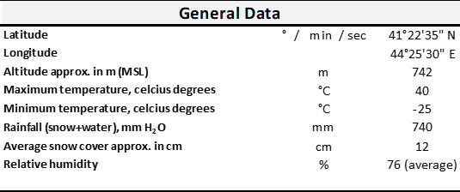
Seismicity Parameters
Annual Exceedance Probability (AEP) | MSK-64 | PGA (g)
1:1,000 year (5% in 50 years) | 8 | 0.20 - 0.30
1:2,500 year (2% in 50 years) | 9 | 0.20 - 0.30
1:5,000 year (1% in 50 years) | 9 | 0.30 - 0.40

General Operation Values

Annual operation time | h | 8200
Annual throughput | t/a | 3000000
Average throughput |  | 366

SUBMISSION REQUEST

It is obligatory to fill in the enclosed appendices, inlcuding links to proposed valves datasheets along with submitting summary proposal covering the following required information.

The technical proposal must include the following documentation:

- Technical specification.
- Installation, Operations and Maintenance Manuals (can be provided later by shortlisted companies).
- List of equipment
- General arrangement drawings for offered equipment
- List of Certifications and tests to be performed during the delivery of valves.

The commercial proposal must include but not limited to:

- Validity of proposal
- References of the mining companies where the vendor’s products were installed by indicating the company/project name, year of installation.
- Total summary of proposed budget by valve types
- Priced to be added to individual valve line in the attached valve lists (appendices)
- Spare parts lists (including price breakdown) needed for commissioning/start-up and 2 years maintenance (at vendor’s discretion).
- Support in installation and commissioning (ideally anticipated budget with indication of daily rate if not only daily rate).
- Delivery terms (no ex-works terms accepted) and general sales conditions.
- Guaranty terms
- Payment terms

ATTACHMENTS TO THIS REQUEST FOR PROPOSAL

- Appendix 1: List of Valves

