QUOTATION SUBMISSION FORM

RFQ Reference: 4200498058 | Date: Click or tap to enter a date.
RFQ ref subject: Visibility items umbrellas, jackets, raincoats with IOM logos

Requirements (Specs/TOR/SOW)

# | Description | Qty | Unit | Date Needed (Expected Delivery Date)
1 | Umbrellas with IOM logo  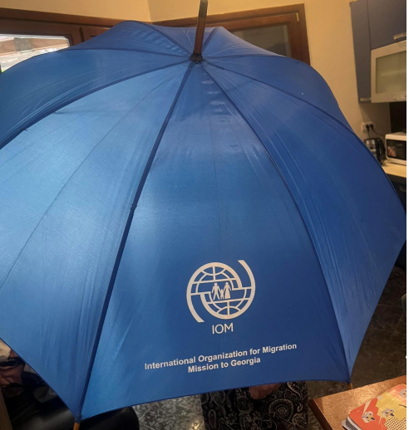 | 100 | Pcs | 07.08.2023
2 | Jackets with IOM logo - 30 size M, 50 size L, 20 size XL  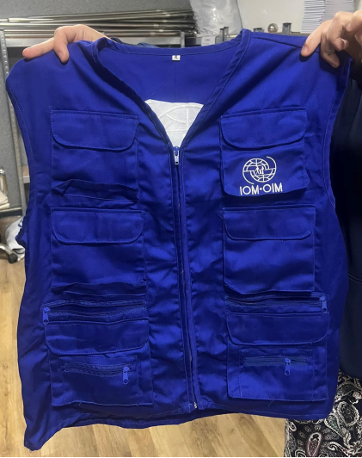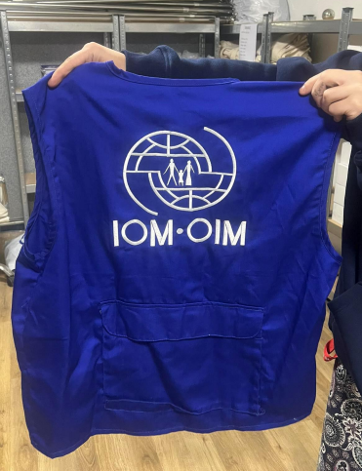 | 100 | Pcs | 07.08.2023
3 | Raincoats with IOM logo standard size  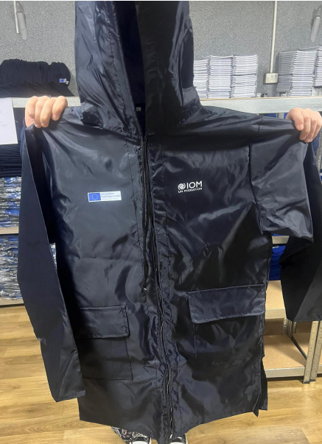 | 100 | Pcs | 07.08.2023

Delivery Requirements:

Currency of the Quotation: GEL
INCOTERMS: Click or tap here to enter text.
Item No | Description | UOM | Qty | Unit price | Total price VAT Excluded
1. | Umbrellas with IOM logo | Pcs | 100
2. | Jackets with IOM logo - 30 size M, 50 size L, 20 size XL | Pcs | 100
3. | Raincoats with IOM logo standard size | Pcs | 100
Total Price VAT Excluded
Transportation Price
Other Charges (specify)
Total Final and All-inclusive Price VAT Excluded

COMPANY PROFILE (Vendor Information Form)
Item Description | Detail
Legal name of bidder* | Click or tap here to enter text.
Legal Address (house no, street name, zip code, city*, region*, country*) | Click or tap here to enter text.
Website | Click or tap here to enter text.
Registration date* and VAT number* | Click or tap here to enter text.  Click or tap here to enter text.
Legal structure | Choose an item.
Business type/industry category* | ☐ Direct Producer/Manufacturing  ☐ Reseller/Distributor/Service Provider
Are you a UNGM registered vendor? | ☐ Yes ☐ No  If yes, insert UNGM Vendor Number
Do you provide services/goods internationally? | ☐ Yes ☐ No  If no, in which country: Click or tap here to enter text.
Contact information* | Company Tel/Mobile: Click or tap here to enter text.  Company Email: Click or tap here to enter text.  Company Website: Click or tap here to enter text.  Contact Person 1:Click or tap here to enter text.  Contact Person 2: Click or tap here to enter text.
Disability inclusive business* | ☐ Yes ☐ No
Women-owned/controlled* | ☐ Yes ☐ No
Bank Information | Bank Name: Click or tap here to enter text.  Bank Address: Click or tap here to enter text.  IBAN: Click or tap here to enter text.  SWIFT/BIC: Click or tap here to enter text.  Account Currency: Click or tap here to enter text.  Bank Account Number: Click or tap here to enter text.  Other relevant information: Click or tap here to enter text.

BIDDER’S DECLARATION OF CONFORMITY
Yes | No
☐ | ☐ | On behalf of the vendor, I hereby represent and warrant that neither the vendor, nor any person having powers of representation, decision-making or control over it or any member of its administrative, management or supervisory body, has been the subject of a final judgement or final administrative decision for one of the following reasons: bankruptcy, insolvency or winding-up procedures; breach of obligations relating to the payment of taxes or social security contributions; grave professional misconduct, including misrepresentation, fraud; corruption; conduct related to a criminal organisation; money laundering or terrorist financing; terrorist offences or offences linked to terrorist activities; child labour and other trafficking in human beings, any discriminatory or exploitative practice, or any practice that is inconsistent with the rights set forth in the Convention on the Rights of the Child or other prohibited practices; irregularity; creating or being a shell company.
☐ | ☐ | On behalf of the vendor, I further represent and warrant that the vendor is financially sound and duly licensed.
☐ | ☐ | On behalf of the vendor, I further represent and warrant that the vendor has adequate human resources, equipment, competence, expertise and skills necessary to complete the contract fully and satisfactorily, within the stipulated completion period and in accordance with the relevant terms and conditions.
☐ | ☐ | On behalf of the vendor, I further represent and warrant that the vendor complies with all applicable laws, ordinances, rules and regulations.
☐ | ☐ | On behalf of the vendor, I further represent and warrant that the vendor will in all circumstances act in the best interests of IOM.
☐ | ☐ | On behalf of the vendor, I further represent and warrant that no official of IOM or any third party has received from, will be offered by, or will receive from the vendor any direct or indirect benefit arising from the contract.
☐ | ☐ | On behalf of the vendor, I further represent and warrant that the vendor has not misrepresented or concealed any material facts during the contracting process.
☐ | ☐ | On behalf of the vendor, I further represent and warrant that the vendor will respect the legal status, privileges and immunities of IOM as an intergovernmental organization.
☐ | ☐ | On behalf of the vendor, I further represent and warrant that neither the vendor nor any persons having powers of representation, decision-making or control over the vendor or any member of its administrative, management or supervisory body are included in the most recent Consolidated United Nations Security Council Sanctions List (the “UN Sanctions List”) or are the subject of any sanctions or other temporary suspension. The vendor will immediately disclose to IOM if it or they become subject to any sanction or temporary suspension.
☐ | ☐ | On behalf of the vendor, I further represent and warrant that the vendor does not employ, provide resources to, support, contract or otherwise deal with any person, entity or other group associated with terrorism as per the UN Sanctions List and any other applicable anti-terrorism legislation.
☐ | ☐ | On behalf of the vendor, I further represent and warrant that, the vendor will apply the highest ethical standards, the principles of efficiency and economy, equal opportunity, open competition and transparency, and will avoid any conflict of interest.
☐ | ☐ | On behalf of the vendor, I further represent and warrant that the vendor undertakes to comply with the Code of Conduct, available at https://www.ungm.org/Public/CodeOfConduct.
☐ | ☐ | It is the responsibility of the vendor to inform IOM immediately of any change to the information provided in this Declaration.
☐ | ☐ | On behalf of the vendor, I certify that I am duly authorized to sign this Declaration and on behalf of the vendor I agree to abide by the terms of this Declaration for the duration of any contract entered into between the vendor and IOM.
☐ | ☐ | IOM reserves the right to terminate any contract between IOM and the vendor, with immediate effect and without liability, in the event of any misrepresentation made by the vendor in this Declaration.

Signature:
Name: Click or tap here to enter text.
Title: Click or tap here to enter text.
Date: Click or tap to enter a date.

If company id not registered in UNGM or with IOM. If supplied to IOM already, please indicate if there are any changes to be incorporated in the vendor information sheet signed earlier
This form is mandatory to fill in and sign by every vendor who submits quotation

