Call for Proposal
May 10, 2023,– Tbilisi
The Austrian Development Agency (ADA), with the financial support from the Delegation of the European Union (EU), Government of Sweden and the Federal Government of Austria, implements the “Green Economy: Sustainable Mountain Tourism and Organic Agriculture (GRETA)” project.

The project implements activities to [1] Improve the business environment for organic agriculture and mountain tourism; [2] create new and improved income opportunities in sustainable mountain tourism and organic agriculture and [3] strengthen the capacity of stakeholders active in these sectors. GRETA is implemented between 2019 and 2023 in selected regions of Georgia covering the Mestia, Lentekhi, Tsageri, Oni, Ambrolauri, Sachkhere, Chiatura and Tkibuli municipalities.
The Austrian Development Agency (ADA) within the GRETA project is announcing CFP- Lafet for Bee Families. The services to be performed and the results/outputs to be achieved under this service contract are summarized in the attached Terms of Reference.

The purpose of the assignment is to purchase Lafet for Bee Families with below mentioned technical specification
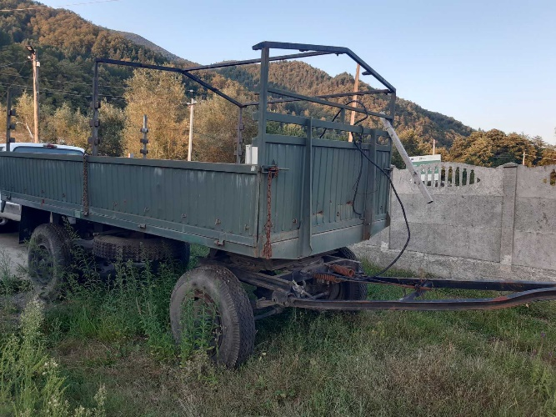
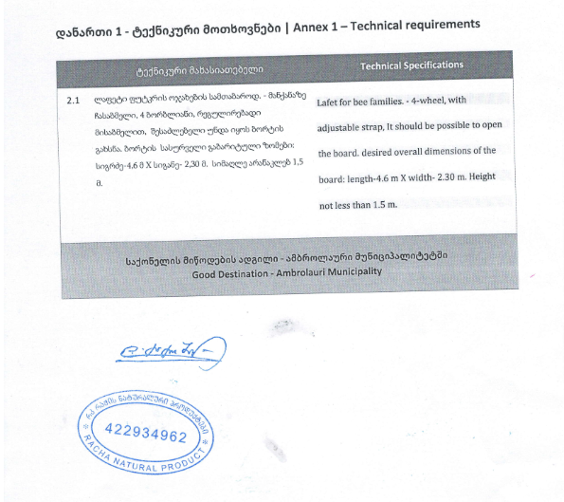

Picture for reference.
Should you/your organization/company be interested in this assignment, we would invite you to provide us with your offer in English language.
1. The TECHNICAL PROPOSAL should comprise of:
- Technical Specification or confirmation, that the Lafet matches organizational needs as per technical specification

2. The FINANCIAL PROPOSAL in GEL (excluding VAT*) **:

- Should comprise of a Price per LAFET

Should you/your organization/company be interested in this assignment, we would invite you to fill in the budget template as below (please do not use any other format for budget or your application will not be considered):
*You can check the VAT exemption status effective within Georgia at RS.GE (ID: 205305560)
***The percentage of the administrative costs must be applied to the sum as follows: (Subtotal - Phase 1 + Subtotal - Phase 2 + Subtotal - Phase 3)
Non-binding offer free of charge in the English language should be submitted via E-mail to mariam.tsereteli@ada.gv.at before 21.09.2023 14:00 in the form of two separate, signed, documents in pdf format. One document clearly marked TECHNICAL PROPOSAL and one document clearly marked FINANCIAL proposal. Please indicate “CFP- Lafet for Bee Families” in the subject line.
The GRETA project/ADA, its donors and implementing company reserve the right to reject all proposals and cancel, reschedule and/or stop the call for Expression of Interest and/or Tender at any time.
Processing of personal data
During initiation and performance of contracts, ADA may process personal data of natural persons that are collected by ADA or transferred or disclosed to ADA by prospective contractors or third parties under their instruction, e.g., personal data of employees, legal representatives, agents or other partners of the prospective contractors or such third parties.
By submitting information to ADA, you, as a prospective contractor, acknowledge:
  - to have taken note of ADA’s Privacy Notice https://www.entwicklung.at/en/media-centre/privacy-notice (’ADA Privacy Notice’);
  - to ensure that each direct or indirect transfer or disclosure of personal data to ADA during the initiation or performance of a contract is lawful pursuant to applicable data protection law;
  - to ensure that all persons, whose personal data are transferred or disclosed to ADA, were promptly and demonstrably provided the ADA Privacy Notice; and
  - that if a contract is concluded and in accordance with its terms, ADA publishes, in particular on the ADA website, information about the contract and the contracting parties.

