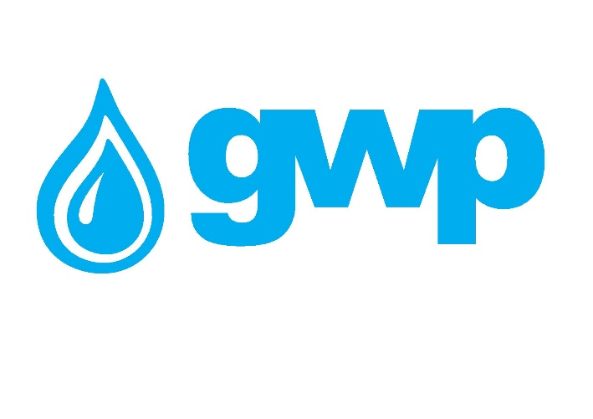

E-Tender Documentation for the Purchase of the Lightings/Projectors and Lightings/Projectors holders.

1.1 Title of procurement
Georgian Water and Power LLC (GWP C/C 203826002) announces electronic tender for the purchase of Lightings/Projectors and Lightings/Projectors holders.
Note:

The purpose of the tender is to select the company for signing a framework contact with the fixing of the unit price of the positions for a period of one year. The minimum quantity of each order and delivery is - 10 - 30 units fom all positions and/or for each existing order, indicating the concrete model and quantity, in accordance with the prices fixed by the chosen company.

1.2 Description of goods (Technical requirements, product, quantity)

Technical requirements, approximate annual quantities by positions/items of the Lightings/Projectors and Lightings/Projectors holders are given in Annex N1.

Note: Buyer reserves the rights to make changes in Annex N1 during and after finishing the e-tender.

1.3 Cost estimation
A Tender Participant shall provide cost estimation in accordance with the Annex N, in both format – PDF and Excel files.

1.4 Form and place for delivery of goods / service / works
Delivery Term shall be DAP, 7 Tskalsadeni Str., Tbilisi, Georgia.
Note: In some cases, the buyer reserves the right to request the delivery of the goods to a location different from the specified address.
1.5 Term of Payment

Payment shall be made by Bank transfer, within the period of 30 (thirty) calendar days from each submited delivered goods.
1.6 Information to be uploaded/provided by bidders for electronic tender:
1. Price list according to Annex 1. Annex 1 must be filled fully and prices must be include all fees;
2. Detailed Technical Specifications, technical datasheets of the offered goods;
3. Extract from the Registry of entrepreneurial and non-entrepreneurial (non-commercial) legal entities issued during last 3 months announcement date of the electronic tender.
Note:
1) All documents and/or information uploaded for the electronic tender by a bidder shall be signed by an authorized person (a letter of attorney shall be uploaded whenever required);
2) It is Preferable All documents and/or information prepared by a pretender to be verified by an authorized person using electronic signature or a stamp of the company.

1.7 Concluding a contract
1) A contract with the winner company will be signed in accordance with the terms of this tender.
2) Georgian Water and Power LLC reserves the right to sign a contract with one or more companies.

1.8 Other requirements
1.8.1 When submitting a bid, a bidder shall not be:
- in the process of filing for bankruptcy
- in the process of liquidation
- in conditions of suspended business activity.

1.8.2 Cost estimation shall be made in Georgian national currency (GEL). Prices must include all costs considered by this tender and taxes specified by the Georgian legislation.
1.8.3 Offer of the bidder shall be valid for 60 (sixty) calendar days from the date of its submission.
1.8.4 Georgian Water and Power LLC reserves the right to determine by itself the tender completion time, to change the tender terms under the notification timely given to the bidders, or to terminate the tender at any stage of its progress.
Georgian Water and Power LLC will identify the winner through the tender commission and inform all participating companies thereof. Georgian Water and Power LLC is not obliged to give a verbal or written explanation to any bidder on any decision made regarding to the tender.
Georgian Water and Power LLC reserves the right to verify any information received from the bidders as well as to obtain information about the company or its activities. If the information provided by a bidder is not true or false, the bidder will be disqualified.
Please, note that Georgian Water and Power LLC will not accept oral request for additional information. Only phone inquiries will be accepted.
Note: Any other information obtained in any other way will not be considered as official and does not generate any obligation from Georgian Water and Power LLC.

1.9 Information for participation in electronic tender:
1.9.1 Any question during the electronic tender process shall be made in writing and communicated through the Q&A platform of tenders.ge website;
1.9.2 To participate in the electronic tender, the company shall be registered on www.tenders.ge;
1.9.3 For instruction on participation in electronic tender through tenders.ge please refer to attached file.
1.9.4 Participation in the e-tender is free of charge.

Contact information:
Contact person: Ketevan Kandelaki
Address: 10 Medea (Mzia) Jugeli str., 0179, Tbilisi
E-mail: kekandelaki@gwp.ge
Tel.: +995 599 19 25 00

