Annex N1
Technical Requirements
Product Name
- LIME
Specifications
Richness: 100,00 %CaO Specific mass: 0,90 kg/l
Acceptable Specifications option 1 – preferable option:
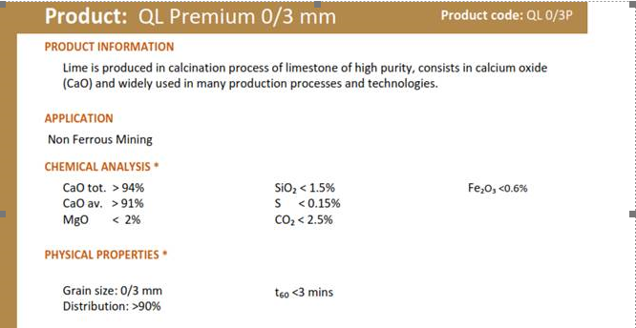
We would like to have the 1st quality product
High CaO values.
Its particule size should preferably be more like a 0 to 1 mm than a 0 to 3 mm

Acceptable Specifications option 2:
Description
Chemical name: calcium oxide
Chemical formula: CaO
Condition: Fine particle powder
Atomic Mass: 56.08
Known as: Lime - slaked and unslaked
Name in accordance with UNE-EN 459: CL 90-Q

Physical characteristics
A single-component substance, calcium oxide, ერთკომპონენტიანი ნივთიერება, კალციუმის ოქსიდი, which contains a small percentage of SiO2, Al2O3, Fe2O3, MgO and CaCO3; It is a raw material of natural limestone. The natural product is obtained by calcination at 1200 ºC, approximately CaCO3.
Appearance | white color, dry, odorless, strong hygroscopic nature
Crystal structure | cubic
PH | 12.4 saturated solution at 25ºC
Density | 940 gr/l
Boiling temp. | 2.850 ºC
Cooling temp. | 2.600 ºC
Weight | 3,34 kg/l 20 ºC
Solubility H2O | soluble in acid, glycerin and sucrose solutions
Reaction with acid | formation of calcium salts by exothermic reaction
Reaction with water | calcium hydroxide is produced during the reaction

Technical data marginal volume
CO2 1 % ≤ 3
Total CaO 97 % ≥ 93
Reaction with water 60ºC 4:00 min ≤ 10
SiO2 0.2 % ≤ 0.7
Al2O3 0.2 % ≤ 0.3
Fe2O3 0.15 % ≤ 0.3
Mg O 1 % ≤ 1.2
Combined H2O 0.1 % ≤ 0.3
S 0.5 % ≤ 0.6

Granulometry:
Sieving Method 5 mm 0 %
Sieving Method 2 mm <12 %

USAGE
The product is used in agricultural, industrial, environment-related activities and livestock farming. For environmental pH and water hardness regulation, remineralization, metal removal, treatment plant and general drinking, industrial or sewage/waste water treatment. For gas treatment of waste fuel and thermal power stations. For soil sabilization, for preparation of construction slurry.
Lime is used for various purposes: neutralizing, melting, caustic, scouring, drying, absorbing, disinfecting, waterproofing and of course as a raw material.

Regulations
UNE-EN 459 - part 1, 2, 3 | Limestone for construction
UNE 80502:2003 | Application of slaked or hydrated lime for soil improvement/stabilization
UNE 80503:2001 | Use of calcium hydroxide in asphalt mixtures
UNE-EN-12518 | In chemical products used for the treatment of water for human consumption - limestone
UNE-EN-12485 | In chemical products used for the treatment of water for human consumption - calcium carbonate, limestone, semi-calcined dolomite

Chemical Abstracts Service Registry Number 1305-78-8
European Invertory of Chemical Substances 215-138-9

Special requirements for shipment - Compulsory
Delivery should be done Bulk in a specialized tanker (Silo truck incl. hydraulic discharge) from which the lime can be fed directly to SILO
Silo loading pressure is 1bar max.
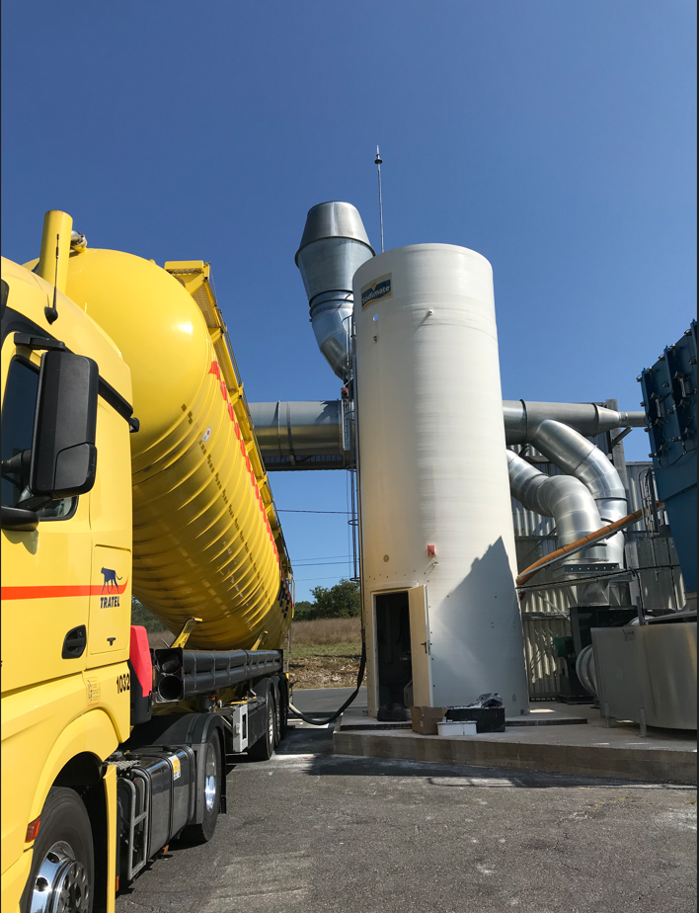

SILOTRUCK should by all means have all the necessary devices (pumps or air impeller) to charge our SILO.

Connection to SILO
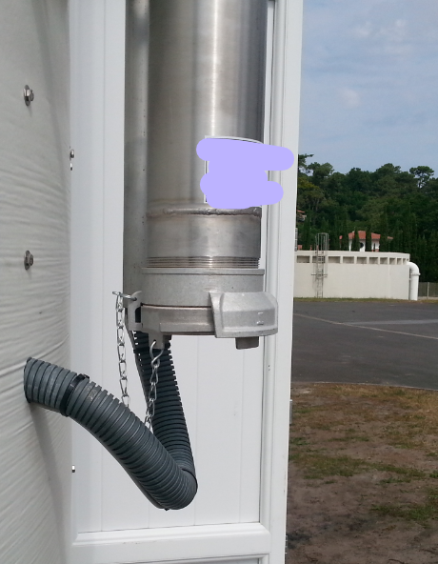

Dimensions of the flange needed
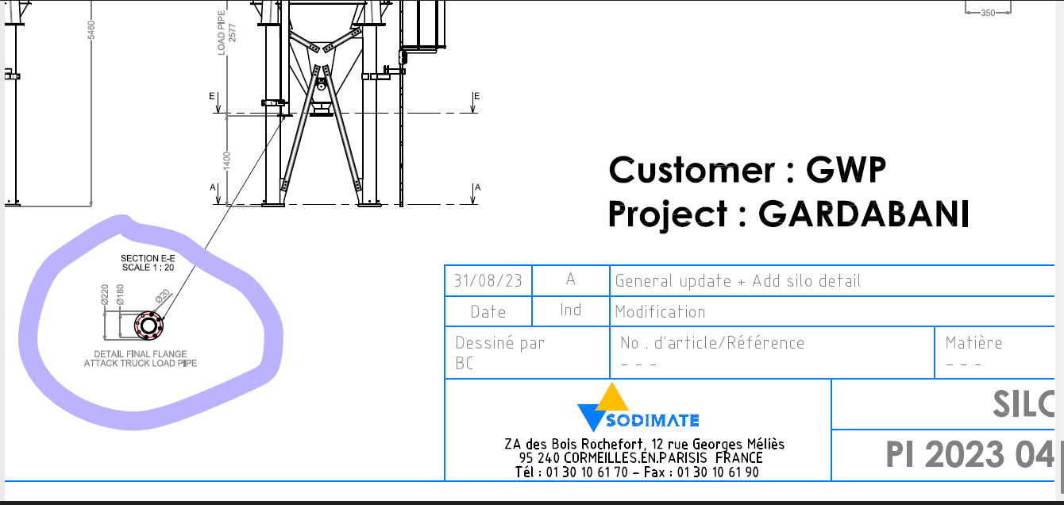

Example video for SILOBUS discharging process –please download:
https://we.tl/t-Okzm8UyPmS

