Real Estate Sales Instructions

Date: 07 March, 2024

Annex 1 – WWF Fraud and Corruption Prevention and Investigation

CONTENT
1) GENERAL DESCRIPTION 2
2) GENERAL CONDITIONS of SALES 3
3) PRICE PROPOSAL SUBMISSION 4
4) COMMUNICATION AND ENQUIRIES 4
5) FORMAT OF THE PROPOSAL 4
6) EVALUATION PROCESS 5
7) ADDENDUM 5
8) DOCUMENTS and confidentiality 5
9) ADDITIONAL REQUIREMENTS 5

General Description
The WWF Caucasus Programme Office (Id. Code 203845964) (referred to as the “SELLER “or “OWNER”) intends to sell a builiding and invites assumed Buyers (hereinafter referred to as “CLIENT”) to submit relevant proposals (hereinafter referred to as “PROPOSAL”).
Asset General Description:
Subject of Sales Real estate

Location Aleksidze Street #11, Tbilisi, Georgia
Zone# 01
Sector# 10
Quarter 13
Plot# 040
Code# 044

Land plot area 2,323 m²
Area of the buildings 528 m²

Real estate located on cadastral code 01.10.13.040.044

Description of object of sales

Sales object (Office building) is represented through the land plot owned by World Wide Fund For Nature (WWF) Caucasus Programme Office and an office placed on it. referred property is situated at 11 Merab Aleksidze Street, Vake-Saburtalo district, Tbilisi. Residential and commercial objects are situated at the adjacent territory of the building. The building is situated at approximately 1.4 kilometers from Tbilisi City Hall and at about 800 meters distance from Heroes’ Square. The nearest metro station (Technical University Station) is located in about 700 meters and Railway Station is situated in 1.6 kilometers distance. The valuation object is situated at 440 meters from the sea level. Land plot has irregular square shape. The entrance to the land plot is located to the north-west side of the plot. Part of it is covered with trees.
There are located two buildings on the valuation object. The main one, which is being used for office purpose (with total area of 528 m²) and another premise, located at the entrance of the land plot. The office space represents two-story building, renovated and totally fit for office purpose.
The Owner reserves the right to negotiate with the CLIENT hand over period of the office to the new owner. The Sales contract shall fully stipulate the relevant terms and conditions.
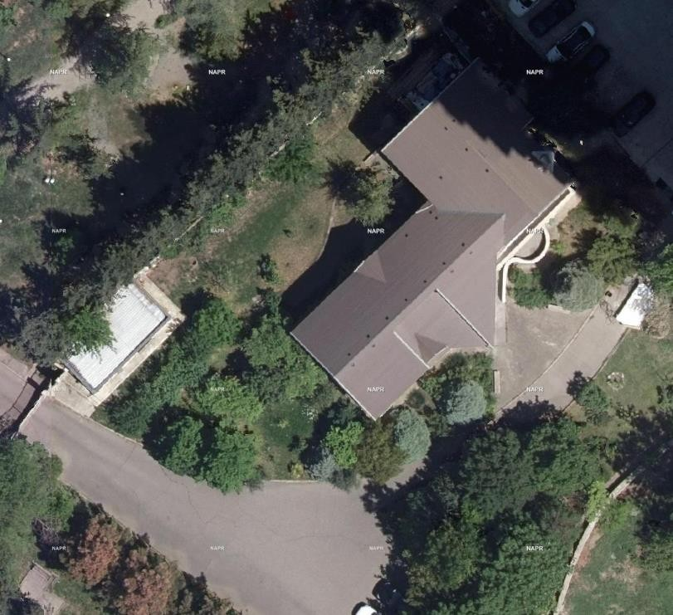
Photo illustration
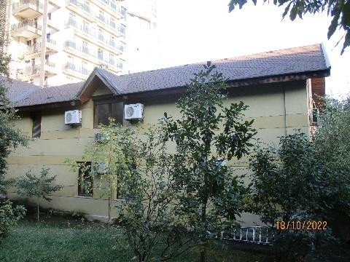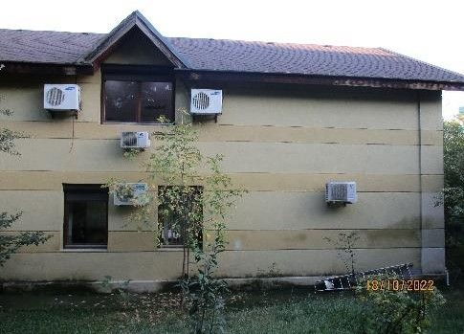
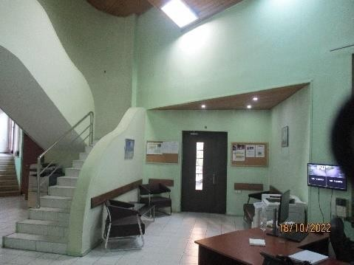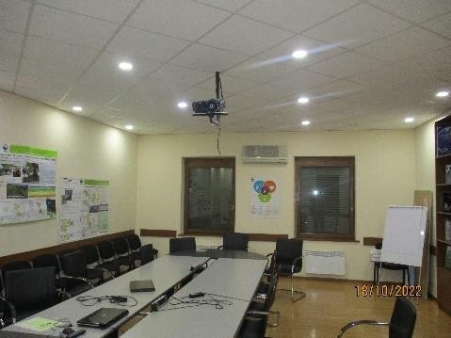
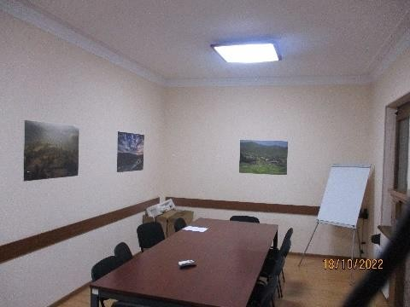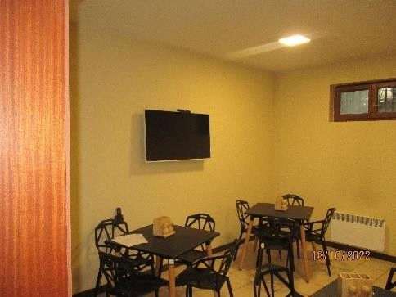

GENERAL CONDITIONS of SALES
1) The interested clients shall submit price proposal (“PROPOSAL”). Proposal shall cover price proposal, terms and conditions of payment, terms and period of asset hand over.
2) The OWNER reserves the right to reject or accept any price proposal. The OWNER is entitled to engage in discussions with any assumed CLIENT to clarify proposals or discuss certain issues with regards to the terms and conditions.
3)The OWNER has no obligation to notify the other CLIENTS of the discussions, clarifications, or other information provided by the assumed BUYER. Any additional information required for preparation of the Proposal shall be distributed to all interested parties.
4) The OWNER reserves the right to award the proposal based on price proposal, payment terms, conditions and period of the building hand over (minimum 1 (one) year period) and other criteria.
5) The OWNER reserves the right in the event the successful CLIENT fails to comply with the terms and conditions as listed, to cancel this contract and award it to another BUYER without penalty or action against the OWNER.
6) The Proposal is not a binding agreement between the parties, submission of a proposal or response by an assumed CLIENT is voluntary.
7) By submitting a price proposal, the CLIENT is deemed to have acknowledged all of the undertakings, specifications, terms and conditions, WWF Fraud and Corruption Prevention and Investigation Policy (Annex 1) contained in the present document, and to be bound by them if the Proposal is accepted. All expenses incurred by the participant in connection with the preparation of its proposal are to be borne by the CLIENT. The OWNER shall not incur any obligation whatsoever toward the CLIENT regardless of whether such proposal is accepted or rejected.
8) An authorized signing officer must sign all Proposals. The Proposal must indicate an individual who is authorized to negotiate and sign on behalf of the CLIENT if other than the signature found on the proposal submission.

PRICE PROPOSAL SUBMISSION
Proposals shall be submitted in closed envelopes indicating the CLIENT’s contact details.

Communication and enquires
  - All enquires and communication regarding this Building Sales Process are to be submitted in electronically to the following e-mail: dbichelashvili@wwfcaucasus.org.
  - Any information and responses to enquiries will be made in writing and distributed by email to all interested parties.
  - The Price Proposal shall be valid within 120 (one hundred twenty) calendar days.

FORMAT of THE Proposal
The Proposal submitted by the CLIENT must be structured as per the below provided instructions:
- General Information about the assumed CLIENT. Extract from the registry/copies of ID documents, Banking Details;
- Terms and conditions of payment;
- Terms and conditions of hand over process and period, considering the OWNERs request;
- Commercial Offer in USD. Unit price per m² and total price;

- The Proposal documentation shall be provided in the English Language.

Evaluation Process
During the evaluation process the OWNER shall envisage the following criteria:
- Price Proposal
- Payment Terms and Conditions
- Office Hand Over Period and Terms
After the initial evaluation of the proposals, the OWNER may conduct additional communication with the assumed CLIENTS for further clarifications. Depending on the price proposal the CLIENT may reconsider the requested minimum hand over period.

ADDENDUM
In the event the OWNER is required to issue notifications of changes or corrections to the proposal package, such addendums shall be emailed. It is mandatory that the OWNER receives confirmation (email) that the CLIENT has indeed received the addendum. Failure to comply with the instructions on an addendum may result in rejection of the Price Proposal.

DOCUMENTS and confidentiality
All documents completed shall be the property of the OWNER and shall not without the consent of the OWNER be used, reproduced or made available to third parties beyond what is necessary in respect of the fulfilment of the Proposal. All documents issued and information given to the Supplier shall be treated as confidential.

additional requirements
The CLIENT shall provide additional information and below listed documentation upon additional request:
- Updated extract from the public registry
- The official confirming statements/letters from the relevant services (public registry and revenue services) that:
- the bankruptcy or financial resolution/assistance procedures are not in progress;
- the company does not have any arrears towards the state budget;
- the legal entity’s property is not arrested or confined by court decisions;
- the statement by the serving bank that accounts are not arrested and there is no encashment;

