TOR for the elaboration of detailed design of Bodorna HPP Dam Monitoring system
Overview:

Georgian Water and Power owe several HPP including Bodorna HPP, which installed capacity is 2.5 MW and the average annual generation of 12-14 million kWh. Bodorna HPP is located in the village of Bodorna, Dusheti municipality, which is 35 km far from Tbilisi.

In 2023, GWP conducted the Due Diligence of the HPP’s dam in order to identify the findings and recommendations necessary for the development of the Dam Monitoring Detailed Project. The study is available upon request and provision of signed NDA, which is attached to the tender documentation. Main recommendation of the study are presented below, and the bidder is obliged to foreseen them during elaboration of statement of method (technical proposal).

Works to be performed:

• Construct a geodetic network with permanent geodetic pillars and reference benchmarks for precise measurements and monitoring of dam deformations.
• Install an automatic monitoring system to continuously measure reservoir water levels.
• Construct flow gauging stations with weirs and automatic level/flow measurement systems to monitor filtration spring flow rates.
• Install electric piezometers for automatization of piezometers within the dam body.
• Install a central data acquisition unit with remote control and telemetry, enabling real-time data transmission and systems integration.
• Conduct testing and commissioning of the monitoring systems, ensuring their functionality and accuracy.
• Prepare comprehensive as-built documentation detailing the installed systems and their configuration.

Recommendations for Monitoring System and Program Implementation identified during Due Diligence
The specific recommendations issued regarding the implementation of monitoring system network for Bodorna dam includes seepage monitoring, dam deformation and settlement monitoring, piezometric network, and reservoir water level measurement system, which are discussed in respective sections below.
These recommendations are based on the findings of conducted site investigations and engineering analysis. Simultaneously, they align with preliminary considerations regarding monitoring and surveillance measures for the Bodorna dam. After further discussion and clarification with the Client, the detailed planning of the monitoring network implementation and program together with the respective technical-economical proposal can be structured, providing an updated foundation for the second stage of the project.

Seepage Monitoring
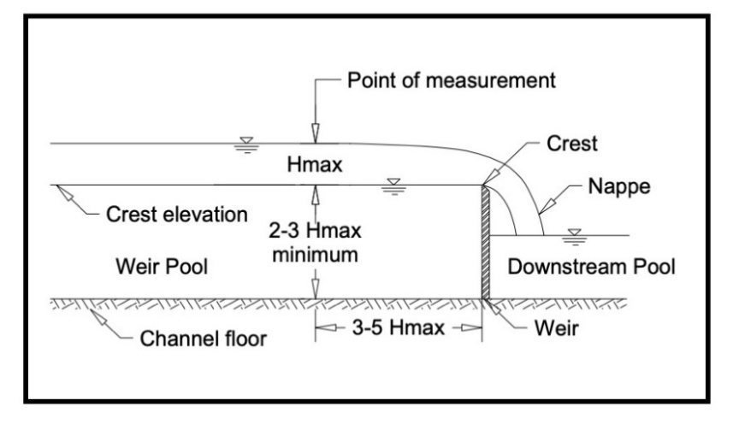
For the seepage monitoring of Bodorna dam, the implementation of a weir flow measurement station, particularly utilizing precast V-notch weir boxes, is recommended. V-notch weirs are hydraulic structures designed to precisely quantify water flow through earthen dams. Configured at 22.5, 30, 45, 60, or 90-degree angles, these weirs enable accurate measurement of seepage volumes and suspended sediment particles transported along the flow. The V-notch box configuration not only provides precise measurements but also incorporates features for the capture and retention of sediments and debris. An inlet baffle plate and the weir plate create a quiescent area, allowing suspended particles to settle, collecting at the bottom of the weir pool. Simultaneously, larger debris is effectively screened from the flow stream by the baffle or weir plates. Constructed from durable, corrosion-resistant materials like stainless steel or high-grade plastics, V-notch weirs ensure longevity in harsh environmental conditions. Equipped with precise flow measurement devices, such as floats or digital sensors, and sediment collection features, they facilitate continuous and comprehensive monitoring. Properly aligned and securely installed, these weirs offer a reliable means of assessing both seepage and suspended sediment, supporting proactive dam safety management for the Bodorna dam and similar structures.
Figure 6.1: V-notch box configuration scheme
Besides seepage location 3.1 (cluster 3) which flows through steel pipe (d=500mm) at all other spring spots could be installed and utilized 22.5-degree sharp crested v-notch boxes which ensures to accommodate the entire flow ranges expected.
Noteworthy, v-notch weir box solution needs consideration and proper organization of construction of collection and intake structures to convey water to the boxes.

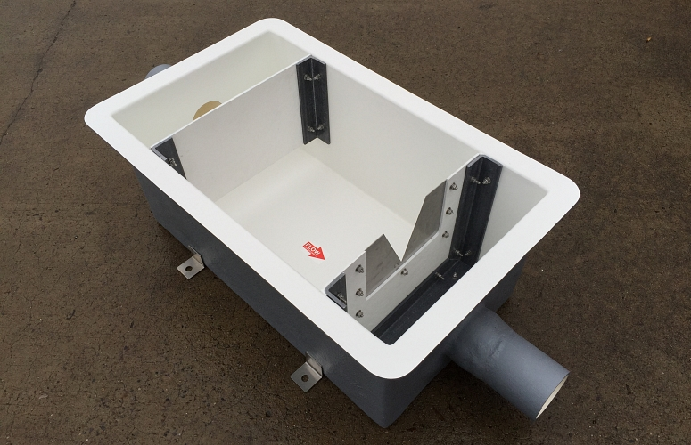
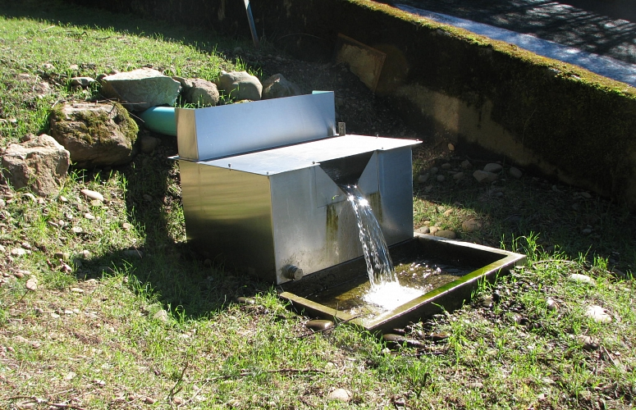
Picture 6.1: V-notch box examples
Regarding flow measurement into the steel pipe (seepage location 3.1), it may be relevant to consider using volumetric weirs, such as those provided by Thel-mar LLC, or circular weirs, considering the ease of installation conditions. Both solutions can be tailored to ensure the accurate measurement of observed flow rates. Alternatively, a V-notch weir remains a viable option, albeit with higher expected implementation costs.
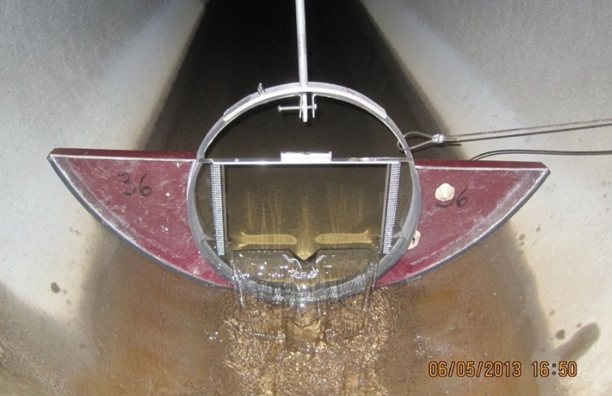
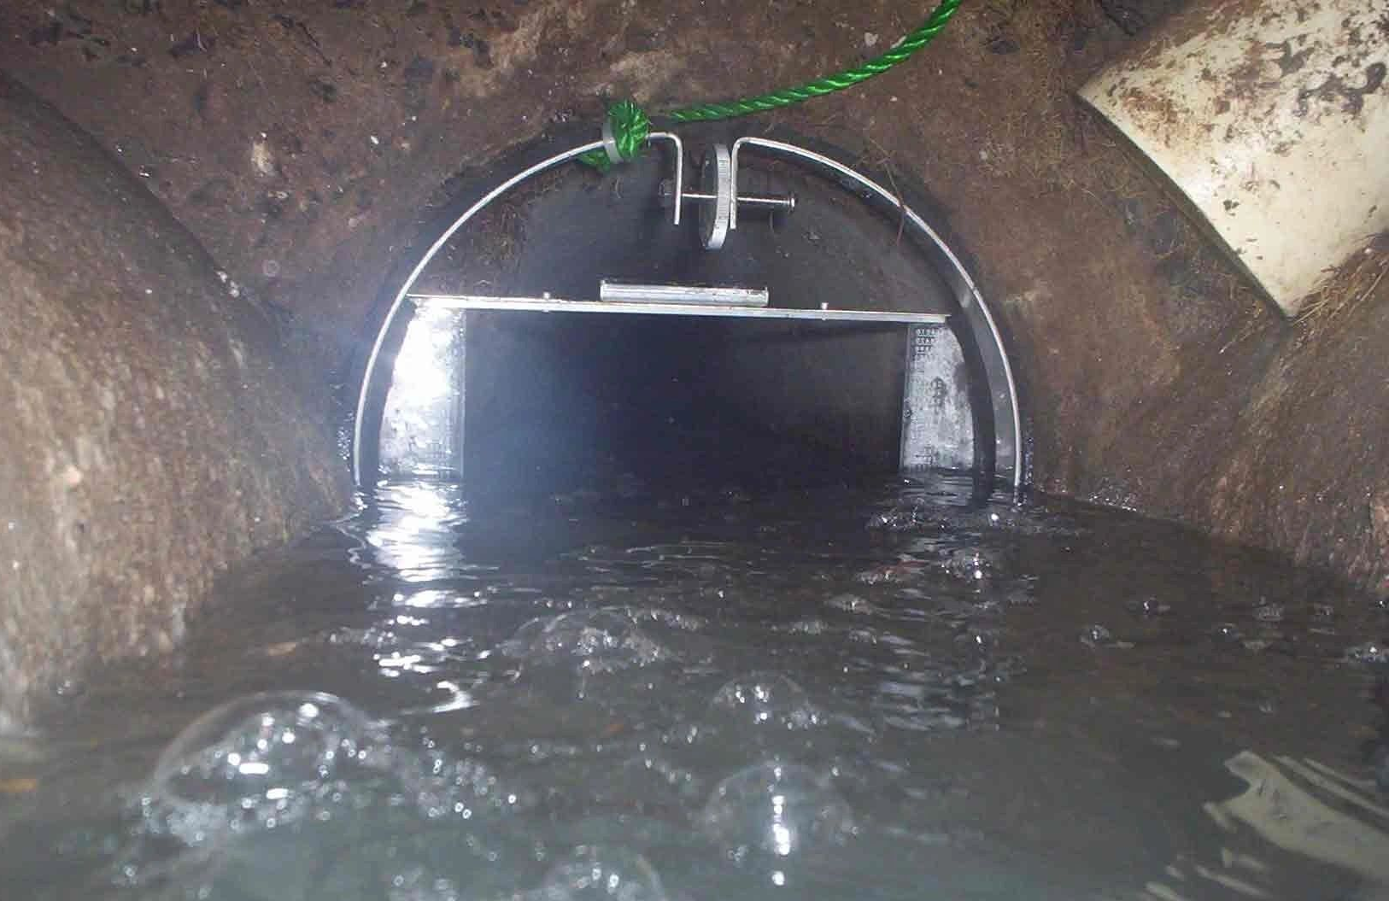
Picture 6.2: Examples of volumetric weir installation
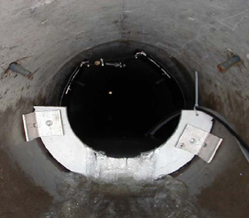
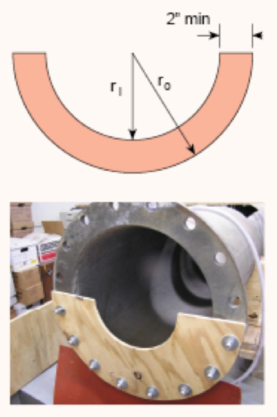
Picture 6.3: Examples of circular weir installation
Finally, all the above-discussed solutions for the seepage monitoring station can be equipped with automatic level monitoring sensors. This integration ensures continuous and near-real-time seepage flow quantity information, offering a cost-effective investment with improved technical considerations for enhanced monitoring capabilities.

Dam Deformation and Settlement Monitoring
Considering the overall findings of the study and potential concerns discussed initially and throughout the project implementation period, it is strongly recommended to conduct systematic dam deformation monitoring. To achieve this, the construction of a geodetic network around the dam perimeter and key areas of interest is advised. Given the dam geometry and surrounding terrain, a conventional geodetic leveling technique is proposed. This involves establishing several permanent reference pillars in stable areas near or around the embankment dam, along with monitoring benchmarks at the dam crest along the perimeter and at specific areas of interest or concern, such as observed settlements near main seepage (cluster 3) and erosion areas at the left embankment toe. For the dam crest, the suggested interval between monitoring benchmarks is 15-25 meters. It is advisable to extend this network to include appurtenant structures such as the spillway, hydropower plant (HPP), water supply intake, etc.
Furthermore, all benchmarks can be equipped with a 5/8’’ screw embedded in concrete, enabling high-precision RTK GNSS monitoring for additional control and 3D deformation monitoring capabilities.
Figure 6.2: Scheme for geodetic pillar installation

Picture 6.5: The example of geodetic monitoring benchmarks with RTK GNSS integration capabilities
Lastly, a monitoring survey program should be developed, potentially integrated with the periodic survey campaigns already implemented for Zhinvali Dam geodetic monitoring for optimized efficiency.
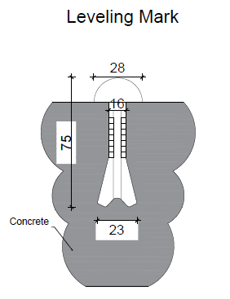
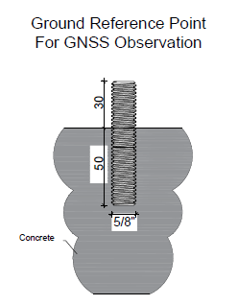
Picture 6.6: Scheme of ground monitoring benchmarks for installation in concrete surfaces such as hydraulic structures

Piezometric Network (level indicator for piezometric network)
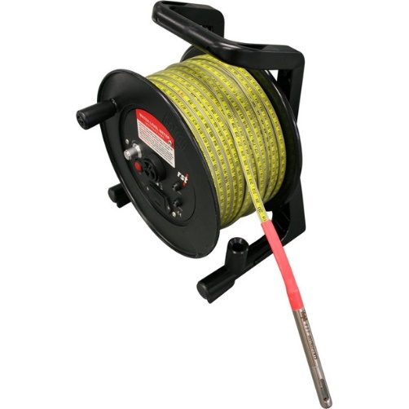
As discussed in the relevant chapters of the present report, standpipe piezometers have been installed in 6 boreholes drilled during the geotechnical investigations. The extent of these installations is deemed sufficient for the engineering analysis conducted within this project scope forms the basis for commencement of the following monitoring purposes. However, it is recommended to consider further extending the piezometric network together with the additional studies that may be anticipated and/or based on the further recommended dam monitoring outcomes. Simultaneously, it is advisable to acquire a water level meter device specifically assigned for the Bodorna Dam, along with training of local personnel to ensure the effective and systematic monitoring of piezometric levels in the existing boreholes.
Picture 6.7: Water level indicator/meter

Reservoir Water Level automatic Measurement System
Based on the information gathered from on-site inspections and discussions with Bodorna Dam personnel, there are currently two water level measurement systems in place. The first system, utilized by the Bodorna reservoir operator, involves a pressure transducer lowered into a steel pipe near the main spillway. The water level information is transmitted to the operator through a CCTV camera installed in the switch cabinet. However, as per the latest information, this system is currently non-operational. The second system is employed by Bodorna HPP, also utilizing a pressure transducer sensor, with the signal integrated into the SCADA system of the plant. To ensure continuous reservoir level monitoring and surveillance, especially considering the non-functionality of the first system, it is advisable to consider installing a radar water level system which shall have a minimum of 8m of the sensing range. This system is known for being maintenance-free, contactless, and highly accurate.
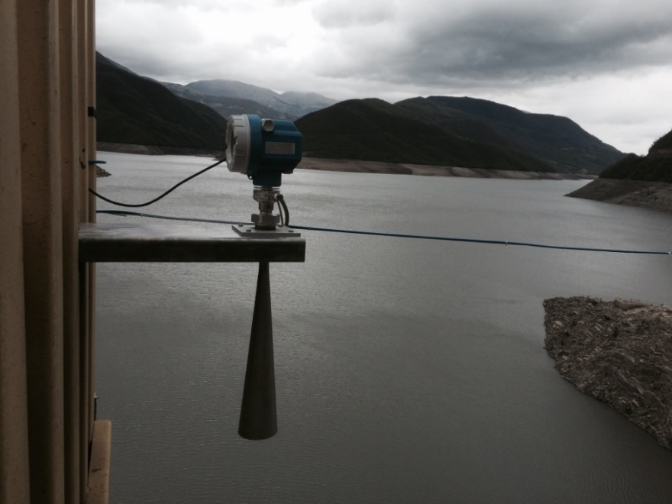
The signal from the radar system can be duplicated and/or transmitted directly to the reservoir operator, Bodorna or Zhinvali HPP, or any remote server or online web platform.
Picture 6.8: The example of reservoir water level radar sensor at Zhinvali reservoir

According this data and site investigation, is mandatory to prepare detail design and approve with GWP.
The following equipment was recommended during the DD study, however bidders are free to propose different decision:
Pos. | Description | Unit | Unit Price | Qty | Total
1 | Seepage Monitoring  Flow gauging stations for seepage springs
1.1 | Construction and workmanship of flow gauging wier station | no. |  | 5
1.2 | Construction and workmanship of flow gauging wier in pipe | no. |  | 1
1.3 | Installation of automatic level/flow measurement system  *Only with local data logging functionality | no. |  | 6
2 | Dam Deformation and Settlement Monitoring  Construction of geodetic network with all necessary accessories
2.1 | Permanent geodetic pillars and/or reference benchmarks | no. |  | 4
2.2 | Monitoring benchmarks (including appurtenant concrete structures) | no. |  | 80
3 | Piezometric Network  Water level indicator for installed standpipe piezometers | no. |  | 1
4 | Reservoir Water Level  Installation of reservoir level automatic measurement system | no. |  | 1
5 | Testing and commissioning of the systems and preparation of as-built documentation | lump sum
6 | Initial survey campaign of all parameters, data processing, elaboration of results and reporting | lump sum
7 | Installation of a central data acquisition unit with remote control and telemetry, and systems integration  * Includes hardware/automatization/telemetry upgrades of all proposed monitoring devices | no. |  | 1

