Terms of Reference for the Design of Picnic Areas in Adigeni Municipality

The National Forestry Agency, with the technical support of the consortium between Zavita d.o.o, Stritih d.o.o and WWF Caucasus are implementing a project Measures for the Sustainable Use of Forest in Adigeni Municipality – Phase 2. The purpose of the project is to improve the sustainable use of forests and to improve the socio-economic conditions of the local population. Slovenian International Development Cooperation funds the project.
The project beneficiaries are the National Forestry Agency of Georgia, the state institution responsible for protecting and managing forests and selling timber and other forest products, and the rural local communities of Adigeni organised in Community Unions involved in the conservation agreements, which would develop modern forestry services and a forest products value chain.
One of the project activities is the implementation of priority actions foreseen in the Forest Recreation Management Plan, including hiking and other trails, camp and picnic sites, visitor information on forests and sustainable forest management. This includes construction of two public picnic areas at sites shown in Figure 1. This project aims to enhance the recreational experience of visitors while preserving the natural beauty and integrity of the forest ecosystem in Adigeni municipality.
The picnic areas will serve as an opportunity to experience nature in an organized and low-impact way and to learn about nature, forests, and forest management. They should provide a tranquil and inviting space for individuals and families to enjoy nature while promoting sustainable practices and environmental awareness. One area is located near Utkhisubani along the main road from Akhaltsikhe to Batumi over Goderdzi Pass. The other one is near one of the Triala lakes south of Adigeni. The first area is expected to receive high levels of visitors after the current road reconstruction is finished. The second site is expected to be visited mainly by the residents of the region in family or social groups.
WWF Caucasus is seeking proposals from qualified companies, individuals or universities to design forest picnic areas using natural materials, sourced locally. This Terms of Reference (ToR) outlines the project requirements, scope of work, tender procedures, and timeline for interested companies to submit their proposals.

Figure 1: Map of Adigeni forests with visitor attractions and the locations of two planned picnic areas (orange arrows).
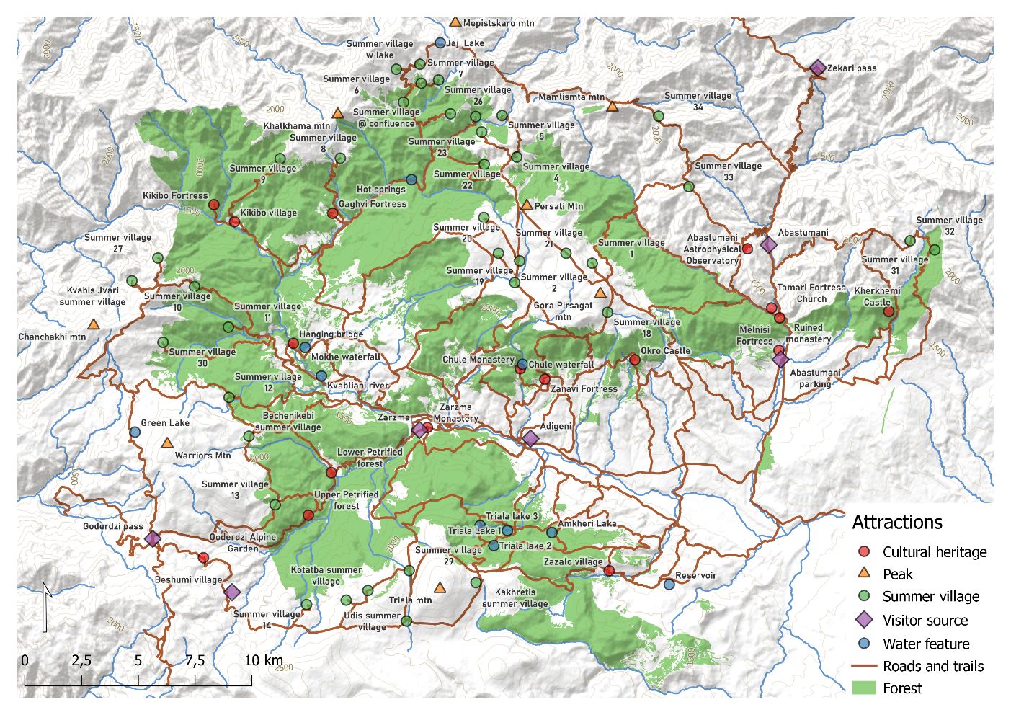

Scope of Works

The selected company will develop a comprehensive design concept for the picnic areas on Triala Lake 1 (X = 41.641270, Y = 42.699868) and Utkisubani (X = 42.5957, Y = 41.6449). The company is expected to reflect the following elements in the picnic areas as described below:
Picnic Place Elements | Triala Lake 1 | Utkisubani
Access road | Access road | Connection to the main road
Parking area | 1 | 1
Network of walking paths | 1 | 1
Information board(s) about the local nature, forests and forest management by National Forest Agency | 1 | 1
Fire pits | 3 | 4
Benches and tables | 3 | 4
Covered sitting area | 2 | 2
A drinking water source | 1 per site. Design only. Specific placement in the picnic areas will be determined based on the available location of water source
A toilet (compostable) | 1 | 2
Waste collection point | 1 | 1
Traditional wooden fencing to protect the users from cattle | 1 | 1
A cottage/shelter for a guard or maintenance person | 1 | 1

Emphasis should be placed on using natural materials that are locally sourced and environmentally sustainable, such as wood, stone (drywall) and gravel. The design should seamlessly integrate with the natural landscape, preserving existing vegetation and topography while enhancing the visitor experience. It should reflect/reference the traditional architectural styles and construction methods of Samtskhe and Adjara.
The design should minimize environmental impact, with minimum changes to the topography, provisions for rainwater management, habitat preservation, and biodiversity enhancement.
The picnic area should be accessible to individuals of all ages and abilities, with pathways, seating, and facilities designed to accommodate diverse needs.
The communication elements (information boards and signs, direction signs) should be developed as an integrated design concept reflecting the brand of NFA and the communication objectives of the Adigeni Forest Recreation Plan as well as of the wider tourism destination management of Georgia. These should be inviting and easily understandable, easy to maintain and not expensive to replace in case of vandalism.

Deliverables

The Consultant is expected to develop a a conceptual design consistent with the local surroundings in the target areas and provide cost estimates of all needed resources.
In particular, the Consultant is expected to provide the following deliverables:
- Photos reflecting existing situation;
- Situation plan and planimetric map showing how the picnic area design concept relates with the natural environment (scale: 1:1000);
- General layout of the map with objects (Scale 1:200);
- Sketches and conceptual drawings (incl. 3D visualisation) of the objects and their locations inside the picnic areas;
- Design concept for the communication elements (information boards and signs, direction signs)
- Estimate of quantities of materials and preliminary cost estimates including construction, operation and maintenance costs;
- Preliminary estimates of man/hours needed for the construction.

Experience
Interested companies or individuals must demonstrate prior experience in designing outdoor recreational spaces, with a focus on local, sustainable and eco-friendly practices. Proposals should include examples of previous projects showcasing the pretendent’s expertise in using natural materials, environmental design, referencing traditional design elements and integration with natural surroundings.

Timeline

Contract Award: Final selection and contract award: June 01,2024
Completion of the design – first area: June 30, 2024
Completion of the design – second area: July 31, 2024

