Assessing Economic Impacts from Climate Change in e3 Models

Large amounts of investments will be needed to enhance the resilience of the national economy towards accelerating risks from climate change. Public investments in enhanced public infrastructure are the basis for private sector adaptation spending to secure productivity in key economic sectors, secure jobs, and income. However, determining where to allocate these investments and which adaptation measures yield the highest economy-wide returns remains a challenge. Macroeconomic models are a complementary tool for sector-specific cost-benefit assessments of adaptation measures, see our [website](https://www.giz.de/en/worldwide/136546.html) for details on the approach: The e3 models are described as “economy-energy-emissions (e3) multisectoral model” and are used to develop and compare scenarios of economy-wide impacts of climate change and adaptation.

To comprehend the benefits of adaptation, it is crucial to simulate potential future economic damages from climate change. These simulations should account for avo45ided damages, besides additional co-benefits, and induced effects of adaptation-related investments. The assessment should cover both slow-onset and acute risks from climate change, key determinants of the physical risks, see Table 1.

*Table 1. Climate-Related Physical Risk Categories*

|  |  |
| --- | --- |
| **Physical Risk Categories** | |
| **Acute Risks** | Increased severity of extreme weather events, such as cyclones, hurricanes, heat or cold waves, or floods. |
| **Slow-onset hazards** | Longer-term shifts in climate patterns (e.g., sustained higher temperatures, sea level rise, changing precipitation patterns) that may cause sea level rise or chronic heat waves. |

*Source: This table's content is reproduced from the* *Recommendations of the Task Force on Climate-related Financial Disclosures[1]*

Acute physical risks refer to those hazards that manifest suddenly or with little warning, often driven by specific events. These events can lead to immediate and severe impacts on human societies, ecosystems, and economies. Acute risks are typically characterized by their rapid onset, short duration, and high intensity. Yet, there is now universal approach of classifying extreme weather events (EWEs), which may be due to varying country-specific climate and weather characteristics. Therefore, the relevant domestic approach should be applied to the economic damage data collection to ensure a good fit to the national climate conditions. Key examples of acute risks include:

* **Extreme Weather Events**; including cyclones, hurricanes, tornadoes, severe thunderstorms, and hailstorms. These events can result in significant damage to infrastructure, loss of lives, and disruptions to economic activities.
* **Heatwaves**. Episodes of unusually high temperatures over a relatively short period, are often accompanied by high humidity. Heatwaves can impact health, agriculture, energy demand, and urban infrastructure.
* **Floods**. Rapid or prolonged inundation of land that is usually dry, caused by heavy rainfall, storm surges, or the overflow of rivers and other bodies of water. Floods can lead to loss of life, displacement of populations, destruction of property, and disruption of transportation and commerce.

Slow-onset physical risks refer to changes in climate patterns due to climate change that occur gradually over time, typically spanning years to decades. These hazards result from shifts in long-term climate variables such as temperature, precipitation, and sea level rise. Slow-onset hazards often have cumulative and systemic effects on ecosystems, societies, and economies. Key examples of slow-onset hazards include:

* **Sea Level Rise**. A gradual increase in the average global sea level due to the thermal expansion of seawater and the melting of polar ice caps and glaciers. Sea level rise can lead to coastal erosion, saltwater intrusion into freshwater sources, loss of coastal habitats, and increased vulnerability to storm surges and flooding.
* **Sustained Higher Mean Temperatures**. Long-term elevation of average temperatures, leading to changes in climate regimes and weather patterns. Sustained higher temperatures can exacerbate heatwaves, alter precipitation patterns, disrupt ecosystems, and impact agriculture, water resources, and human health.
* **Changing Precipitation Patterns**. Shifts in the frequency, intensity, and distribution of rainfall and snowfall over time. Changes in precipitation patterns can lead to droughts, water scarcity, floods, soil erosion, and disruptions to agricultural production and other water-dependent industries.

Simulating future economic losses due to acute risks and slow-onset hazards is key for climate-sensitive macroeconomic modelling. However, it is important to acknowledge the limitations of current modelling approaches and the need for improved data sources to enhance the accuracy of assessments. An assessment of past economic impacts is critical to identifying key hazards and their specific impact channels on economic processes. This historical analysis is also needed to establish a baseline damage level that can be simulated to increase in the future, according to global climate scenarios that are to be translated into country-specific climate hazard projections.

The following concept outlines an approach currently piloted by the CRED project and its partners. The approach is open to further improvement, notably as the data sources will continue to improve in terms of scope (e.g., impact channels) and granularity (e.g., the spatial and temporal resolution of past events and projected changes in climatic variables). By addressing these limitations, the accuracy and reliability of future economic damage assessments can be significantly enhanced.

The primary aim of this concept is to provide guidance to public sector actors and supporting organizations with an overview of necessary steps to collect country-specific data with a limited budget. This acknowledges the challenges faced in data collection and emphasizes the importance of continuous improvement to ensure robust and reliable assessments of economic impacts from climate change.

## Key Steps in Assessing Economic Damages from Climate Change

Macroeconomic climate resilience modelling applies the IPCC climate risk framework (Figure 1) to systematically assess the exposure and vulnerability of economic processes to weather and climate events. Furthermore, this approach aligns with the principles explained in Climate Risk Sourcebook[2]. Understanding potential economic damages is crucial for identifying effective adaptation options, as adaptation from an economic perspective is only viable when the reduction in avoided damages and co-benefits exceeds the costs of the public investments.

*Figure 1: IPCC climate risk framework*

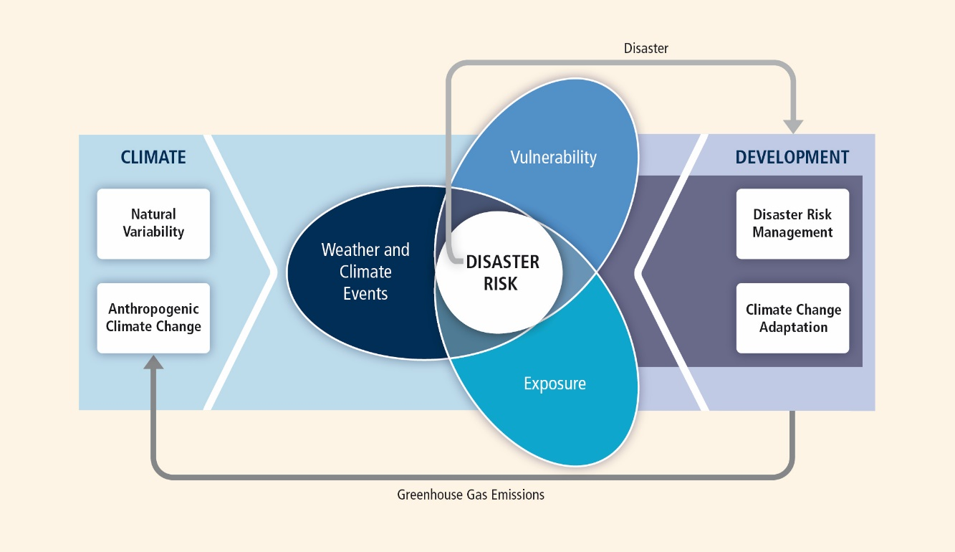

*Source:* [*IPCC*](https://www.ipcc.ch/report/managing-the-risks-of-extreme-events-and-disasters-to-advance-climate-change-adaptation/summary-for-policymakers/spm_fig1/)

The process of collecting data on economic damages from climate change involves a series of steps each of which requires specific information collected in a certain format (see Figure. 2). For that, GIZ and partners will provide Excel templates to ensure full alignment with the macroeconomic e3 model.

To estimate economic damages from climate change, a systematic approach is adopted, beginning with a comprehensive assessment of climate risks. This involves reviewing existing studies and creating a baseline of climate-related risks for key sectors of the national economy, identifying key hazards, and shortlisting them. Subsequently, climate hazard scenarios are developed to project the future occurrence and development of these key hazards based on Shared Socioeconomic Pathways (SSP). The assessment then delves into past damages using a bottom-up approach to compile data on economic damages caused by identified hazards. Bottom-up approaches can provide insights into the sectoral and hazard-specific distribution of economic damages from the past. Simultaneously, data on projected future economic damages from identified hazards in economic sectors are collected using a top-down approach. Top-down approaches are well-suited to estimate future total economic damages at the country or global level, providing an overall assessment of the potential economic impacts from climate risks. Lastly, these two datasets are integrated to simulate future economic damages through scenario creation. Robust damage estimations of projected climate change impacts can be derived by combining top-down and bottom-up approaches. This process involves benchmarking bottom-up data with top-down data to provide a comprehensive outlook on the potential economic impacts of climate change. Combining top-down and bottom-up approaches involves supporting macroeconomic models with sector-specific assessments to provide comprehensive estimations of future economic damages from climate change.

Through this approach, policymakers and stakeholders can better understand the magnitude and distribution of economic risks posed by climate change and formulate targeted adaptation strategies to mitigate them effectively.

*Figure. 2: Key steps for assessing potential economic damages*

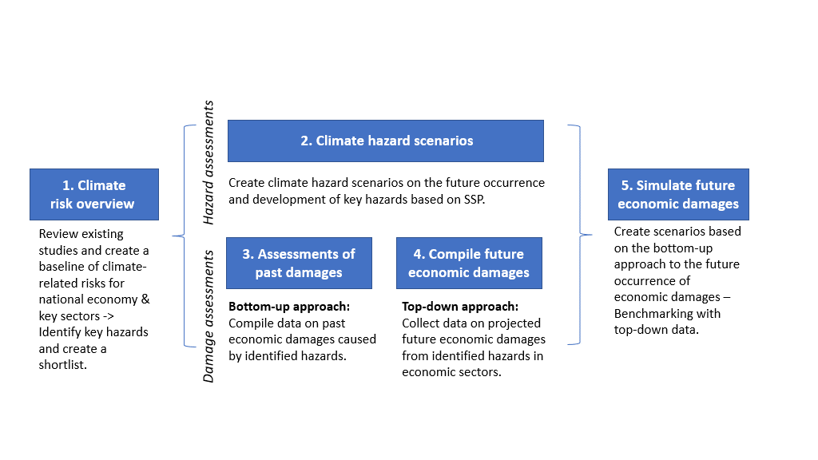

*Source: Own figure adopted from the* [*Climate-Resilient Economic Development (CRED)-Handbook*](https://www.giz.de/de/downloads/giz2023-en-handbook-macromodelling-resilience.pdf)

# Climate Risk Overview

The Climate Risk Overview provides a foundational assessment of the existing and emerging risks caused by climate change to the national economy, serving as the starting point for assessing future economic damages. This entails gathering studies on the economic losses (and potential benefits) induced by climate change on the global economy, including metrics like losses in GDP depending on the region and temperature rise of selected scenarios (see Table 2).

*Table 2: Estimated damages from climate change on regions of the world*

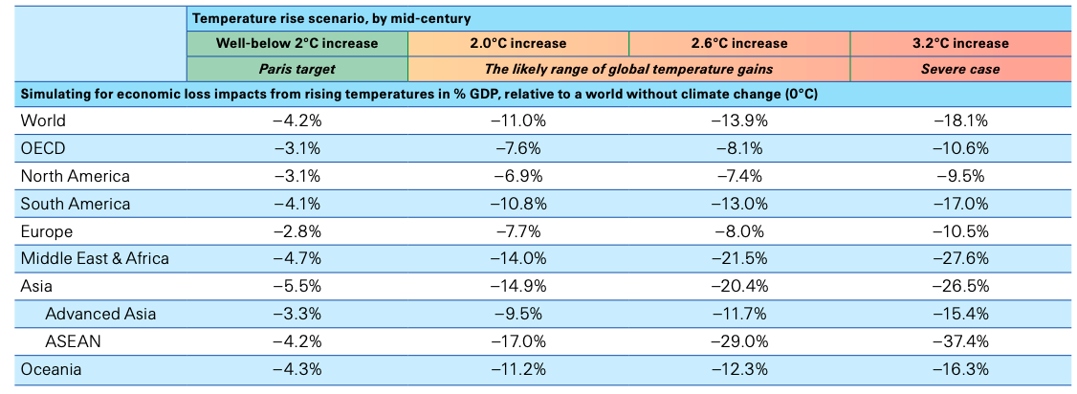

*Source: (Swiss Re, WEF 2021)*

Conceptually, it is important to distinguish between material climatic hazards and the development of disaster risk management and climate change adaptation that makes regions or economic sectors vulnerable. Economic vulnerability to climate change reflects the economy’s sensitivity to be negatively impacted by EWEs (acute physical risks) and slow onset events resulting from increasing climate change. For instance, the depletion of water resources is a risk to the economy only to the extent that agriculture or industry is exposed and relies on water and a decrease in availability. Adaptation is thus the process to reduce vulnerability and reduce the associated risks.

The overview of national climate risks starts from existing reports but then takes an economic perspective to identify key economic sectors and impact channels susceptible to climate risks. A comprehensive risk assessment further identifies and prioritizes key hazards driving national economic risks from climate change to then include it in a shortlist for subsequent steps. This process aligns with the conceptual framework provided in the [Climate Risk Sourcebook](https://www.adaptationcommunity.net/climate-risk-assessment-management/climate-risk-sourcebook/) published by GIZ, based on the most recent IPCC report (AR6) is. The recently published [European Climate Risk Assessment (EEA 2024)](https://www.eea.europa.eu/publications/european-climate-risk-assessment) can serve as a differentiated example.

Based on the overview of the country-specific climate risks, an understanding should emerge on what are the critical climate hazards driving those risks. Resulting from that, a shortlist comprising 5 to 10 key hazards and impact channels needs to be made as a basis for the data collection process. Common climate hazards encompass acute EWEs, such as heat waves, severe storms, and floods, as well as slow-onset events such as sea level rise and desertification. The following guiding questions provide an orientation for compiling a comprehensive climate risk overview:

* Which climate hazards are most common in the country?
* What kind of impact categories and damage categories exist?
* Which key economic sectors are most vulnerable/exposed?
* What are past damages and losses from climate change-related events?

For the EU, the [PESETA IV research project](https://joint-research-centre.ec.europa.eu/peseta-projects_en) lists various hazards and which economic consequences are to be expected, for example in the case of [droughts](https://joint-research-centre.ec.europa.eu/peseta-projects/jrc-peseta-iv/droughts_en) or for [energy supply](https://joint-research-centre.ec.europa.eu/peseta-projects/jrc-peseta-iv/energy-supply_en). Yet, similar comprehensive work on hazards and resulting economic consequences is scarce. Therefore, further research and analysis are imperative to enhance understanding and preparedness for climate-related risks and their economic implications.

# Climate Hazard Scenarios

Creating climate hazard scenarios requires an understanding of future hazard risks by combining past frequency data with projections of likely developments under climate change. Generally, future climate risks are described in terms of changes in intensity and probability of occurrence relative to a historical benchmark or averages. A distinction between both intensity and probability helps to identify suitable climate adaptation measures, as both aspects can be met with different considerations. E.g., when considering building a dam against floods, it is important to know how each frequency and intensity changes. Higher probability can be met with a more robust construction while intensified impact with higher water levels can be alleviated with elevated construction. For this purpose, past levels of chronic risk (e.g., heat stress from temperature) or occurrence of EWEs like floods serve as benchmarking and at the same time for future projections.

To understand how climate hazards will develop in the future, SSPs[3] describe different socio-economic scenarios. In the Sixth Assessment Report of the IPCC, SSPs are combined with different levels of climate change, formerly known as Representative Concentration Pathways (RCPs)[4] in the Fifth Assessment Report (AR5) of the IPCC. This framework differentiates between a range of climate change scenarios used for global analysis. For the country-specific scenarios, we propose considering low (SSP1-2.6), medium (SSP2-4.5), and high levels of climate change (SSP5-8.5), each with corresponding assumptions on global mitigation efforts. Depending on the selected scenario, the slow-onset and acute climate risks increase in different rates, as the level of climate change drives the intensity and occurrence of climate hazard events. Therefore, the future estimated frequency of occurrence (probability) of EWEs is adjusted based on the climate scenario. The choice of SSP scenario directly influences the projected climate hazards and associated economic impacts that are assessed.

*Figure 3: Selected indicators of global climate change from CMIP6 historical and scenario simulations*

Ein Bild, das Text, Screenshot, Diagramm, Reihe enthält.

*Source:* [*IPCC (2021)*](https://www.ipcc.ch/report/ar6/wg1/figures/chapter-4/figure-4-2)

Data for benchmarking and the probability of key climate hazards under different SSP scenarios need to be collected from international, national, or local climate models and reports. Most climate models provide probabilities of EWEs in the future, through which the increased likelihood in the future under a specific SSP scenario compared to the past can be determined. Climate hazards related to weather (e.g. number of hot days, droughts, extreme precipitation etc.) and the increase in intensity and probability per country can be calculated using publicly available climate data sources (e.g. [World Bank website](https://climateknowledgeportal.worldbank.org/download-data)). In the case of riverine floods, [Aqueduct Floods](https://www.wri.org/data/aqueduct-floods) shows how the occurrence of a specific flood type (e.g., 20-year floods) increases under climate change.

For a comprehensive understanding of hazards resulting from climate change, spatial disaggregation is necessary, as effects differ significantly by region. Regarding droughts in Europe, [PESETA IV](https://joint-research-centre.ec.europa.eu/peseta-projects/jrc-peseta-iv/droughts_en) shows a strong increase in the frequency of events and some increase in the intensity of extreme events in north-western (Atlantic) and southern Europe (Mediterranean), while hazards decrease in northern (Boreal) and central Europe (Continental).

*Figure 4: Fraction of area exposed in drought occurrence for three global warming scenarios*

Ein Bild, das Text, Screenshot enthält.

*Source:* [*PESETA IV*](https://joint-research-centre.ec.europa.eu/peseta-projects/jrc-peseta-iv/droughts_en)

As the probability of certain types of EWEs changes heterogeneously, it is suggested to further differentiate some EWE categories. For instance, different flood types have been observed in Georgia: Annual floods resulting from meltwater, “10-year floods” with higher water levels than usual, and 100-year floods that are distinctly destructive due to exceptionally high water levels. Estimations from the Aqueduct Tool suggest that historical 10-year floods will occur twice as often (every 5 years) under the SSP5-8.5 scenario, while 100-year floods will occur every twenty years. Thus, the probability of different flood categories in Georgia increases between two and five times compared to the past.

The potential future country-specific hazards should be created in a unified format for all impact channels and hazard types considered. Additionally, expected probability changes for these hazards, including regional disaggregation, if possible, should be provided. For more complex impact channels, notably water-related hazards (drought and flood events), it is advised to generate country-specific datasets. These datasets should outline historical climate patterns, categorize economic damages, and identify probability and intensity trends per hazard category. Hazard scenarios should also include a high-impact damage category not represented in historical data. Firstly, the observational time is limited, and secondly, recent EWE have exceeded existing extreme values in almost all countries. These events should be included with a low but increasing probability.

Estimating the probability of high-impact damage events that exceed historical extremes is a critical yet challenging aspect of developing comprehensive climate hazard scenarios. The observational record is often limited, especially for rare, catastrophic events, making it difficult to establish robust statistical relationships. Additionally, as the climate continues to change, the frequency and intensity of these extreme events may increase in non-linear ways, exceeding past observations and straining the capabilities of existing models. Uncertainties in future climate projections, especially at regional scales, further complicate efforts to reliably quantify the changing probability of such high-impact occurrences. To address these challenges, the scenario analysis should incorporate expert elicitation, explore a range of plausible scenarios (including high-end, low-probability outcomes), leverage ensemble modeling to characterize uncertainties, and account for the compounding effects of multiple climate hazards.

# Assessment of Past Damages – Bottom-Up Approach

Economic damages from past and current impacts of climate hazards provide valuable evidence and guidance for anticipating future effects of ongoing climate change. Therefore, these indicators play a critical role in modelling potential future economic damages and impacts from climate change. The e3 models use a bottom-up approach, where economic damages from climate change are integrated from specified sectoral and regional assessments. The aim of this approach is to identify and consolidate current and past economic damages from EWEs such as flooding or drought and extrapolate these damages into the future based on the increased severity of climate hazards (see step 2 hazard assessment).

To assess economic damages the basic approach involves creating a shortlist of the climate hazards and analysing data on past economic impacts from these hazards. The objective is to estimate baseline damages from key hazards for general economic sectors and other economic variables (e.g., labour productivity). It is important to note that usually only a few EWEs categories or events cause most economic damages. In Germany, for example, droughts in 2018 and 2019, and a single flood in 2021, accounted for about 50% of damages from EWEs between 2000 and 2021.

In the context of the CRED-supported e3 models, this involves creating an Excel sheet (see Figure 5) to collect all available information from national authorities, experts, and online resources on key EWEs/ climatic hazards and reported damages and impacts. Damages should ideally be disaggregated by region (preferably statistical regions) and economic sector(s) (at least general categories like agriculture and forestry, services, buildings, and infrastructure). In cases where existing damage reports are incomplete, estimations should be made and verified with national partners to ensure sufficient coverage of past damages. If sectoral data is insufficient, distinguishing between different damage categories can help formulate sectoral assumptions (e.g., attributing dead livestock to agriculture). The assessment should ideally cover at least the past 30 years and cover the majority of known total damages per hazard.

For a comprehensive understanding of the impact of a hazard, the assessment should cover as many economic aspects as possible, including direct economic asset damages, losses in asset production (e.g., damaged infrastructure, livestock, and crop losses), and relevant impacts on economic processes (see [PESETA IV](https://joint-research-centre.ec.europa.eu/peseta-projects/jrc-peseta-iv/droughts_en) as an example). Relevant economic impacts from climate change include:

* Reduction in economic productivity
* Lower labour productivity
* Increased demand for cooling / lower demand for heating and healthcare services
* Impaired hydropower generation
* Reduced thermal power generation capacity due to insufficient cooling water
* Reduced pasture productivity
* Price increases due to scarcities (e.g., in transport or for food)
* Higher insurance premiums
* Reconstruction costs for damaged infrastructure

*Figure 5: Example of Excel-based climate damage database in Kazakhstan*

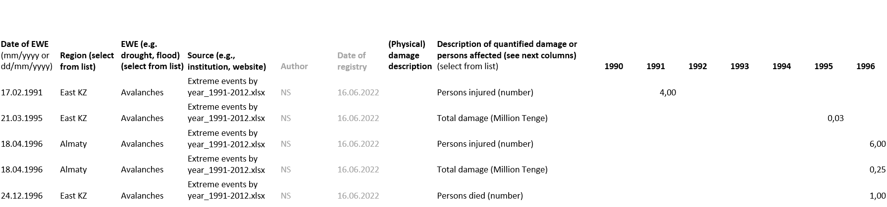

*Source: Own template.*

Based on the collected damages and impacts of key hazards in a country, the baseline of economic damages per EWE per year and per region can be derived. In Kazakhstan, we have created an Excel-based climate damage database, which summarises the economic damages from EWEs from the past 35 years. In contrast to economic data that is regularly published by national statistical offices, climate damage data is not provided as comprehensively and systematically. Thus, time-consuming desk research and contact to relevant experts must be established to obtain the necessary data. This information provides the basis for simulating future economic damages from climate risks. In Mongolia, we have summarized the number of heavy rains and floods spanning from 1996 to 2023 (see Figure 6) to further quantify the economic damages derived from these weather events. By analysing the probability trends inherent in these events, we aim to enhance our capacity for future predictions.

*Figure 6: Heavy rain and floods (number) from 1996 to 2023 in Mongolia.*

*Source: Own compilation.*

# Compile Future Economic Damages – Top-Down Approach

The top-down approach involves conducting an extensive literature review or desk study to compile and systemize available country- or region-specific reports on future economic damage estimates. Sources such as the World Bank Climate Change Development Report (CCDR), and other credible sources, such as peer-viewed articles[5], should be consulted, covering relevant SSPs and related RCPs, as well as relevant sectors. This overview serves as benchmarking for estimating future economic damages in the next step. The data should include future economic damages (e.g., until 2050) from increasing EWEs – by probability and/or intensity - as well as climate-induced slow-onset hazards from climate change identified in the climate risk overview.

Figure 7 shows an example of how this data can be compiled. First, the identified key hazards from the climate risk overview are listed, and then the most important sectors affected by those hazards are aligned. Country-specific data improves the overall validity of the model’s outcomes. However, in cases of limited data availability, it is recommended to compile estimates on future economic damages from neighbouring countries or at the relevant regional level. The data collected from credible climate modelling approaches can serve as supplementary data to the bottom-up approach in the e3 modelling. Relevant data mainly comprises effects on prices, final demand (private and public consumption, and investment) production, imports and exports as well as employment, if possible on the level of economic sectors covered by the e3.cc model.

*Fig. 7: Excel template for collecting projected economic damages per SSP scenario*

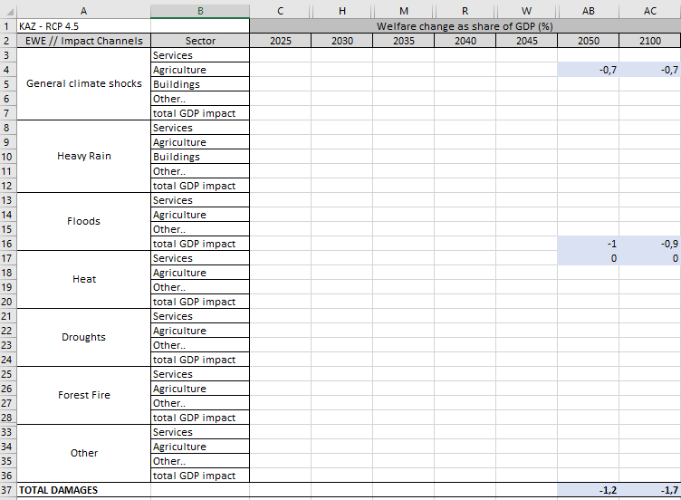

*Source: own template.*

# Simulate Future Economic Damages

The collected economic damages data from past and estimated future impacts of climate hazards provide valuable evidence and provide the basis for simulating potential future economic damages and impacts from climate change. Initially, a baseline of future economic damage scenarios should be established using data from the bottom-up approach. In this baseline, past economic damages from EWEs like flooding or drought are extrapolated into the future. To integrate the effects of climate change, the probability and intensity of EWEs will be adjusted in combination with climate projections (e.g., SSP5-8.5, SSP2-4.5), as shown in Fig. 8. Moreover, the direct impacts of EWEs are implemented as effects on human behaviour, production factors, and infrastructure, including:

* Household consumption expenditures
* Exports & Imports
* Investments
* Prices of products, labour, capital
* Labour productivity

*Fig. 8: Simulating possible damages per climate scenario and year in the future*

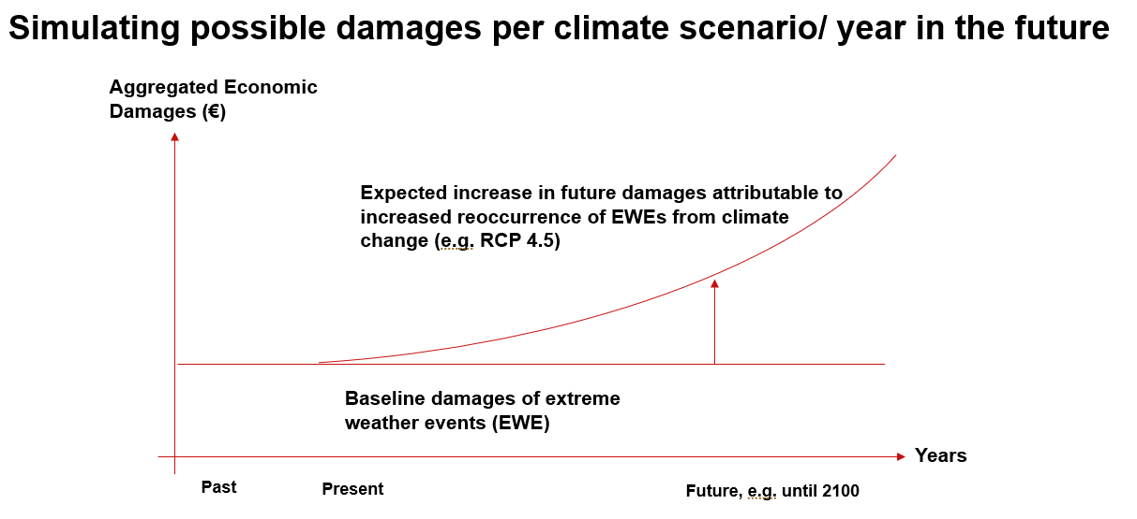  
*Source: Own figure.*

However, the bottom-up approach has limitations in terms of capturing emerging new risks that are difficult to anticipate and regarding slow-onset hazards. The scenarios based on past climate damages are not a complete guide to the future and provide only a limited proportion of the impacts to be expected.

Due to the high uncertainty inherent to the bottom-up approach, it is recommended to benchmark the baseline scenarios to the complied data from the top-down approach. This approach combines the strength of both approaches to derive sector specific and regionally disaggregated estimates of climate impacts. Bottom-up data can inform and calibrate the top-down models. The key steps include:

* Translating top-down impacts into yearly GDP scenarios per considered SSP (relative to baseline scenario with no climate change).
* Calculating yearly total bottom-up GDP impact per SSP (combining domestic, international, and transboundary impact channels)
* Calculating “adjustment ratio” for matching top-down and bottom-up estimates per year
* Including adjusted bottom-up damages into model.

This procedure ensures that the modelled damages align with damage estimates from existing studies while adding the sectoral and spatial disaggregation necessary for estimating the avoided economic damages from adaptation actions.

The data collected in the steps above allows integrating climate hazard scenarios and economic vulnerability in the e3 models based on the assessment of past economic damages and compiled future economic damage estimates. The simulated future economic damages in the e3 models are driven by the increase in probability and intensity of the climate hazards.

The damage data collected must be translated into economic variables and allocated to the economic sectors that are part of the e3 models. Depending on the kind of damage data, these are implemented either as price or demand shocks for the corresponding economic sectors. Crop damages and the resulting need for higher imports or price increases are contributed to the sector agriculture. Damages to infrastructure, e.g. buildings and roads are implemented as additional (involuntary) investments, while the replacement of destroyed furnishings of private households causes additional (involuntary) household expenditures.

*Figure 9: The e3 model approach*



*Source: Großmann et al. 2022, based on GWS 2022*

## Additional Resources

OECD 2021 [Managing Climate Risks, Facing up to Losses and Damages | OECD iLibrary (oecd-ilibrary.org)](https://www.oecd-ilibrary.org/environment/managing-climate-risks-facing-up-to-losses-and-damages_55ea1cc9-en)

[Challenges and innovations in the economic evaluation of the risks of climate change - ScienceDirect](https://www.sciencedirect.com/science/article/pii/S0921800922000994?via%3Dihub)

[The missing risks of climate change | Nature](https://www.nature.com/articles/s41586-022-05243-6)

<https://www.weforum.org/agenda/2021/06/impact-climate-change-global-gdp/>

GIZ 2022 [Handbook on Macroeconomic Modelling for Climate Resilience (giz.de)](https://www.giz.de/en/downloads/giz2023-en-handbook-macromodelling-resilience.pdf)

1. The Task Force on Climate-Related Financial Disclosures “[Recommendations of the Task Force on Climate-related Financial Disclosures](FINAL-2017-TCFD-Report-11052018.pdf%20(bbhub.io))”: Last accessed on 19 April 2024
2. <https://www.adaptationcommunity.net/wp-content/uploads/2023/10/giz_2023_Climate_Risk_Sourcebook.pdf> last accessed 19 April 2024
3. Shared Socioeconomic Pathways (SSPs): scenarios that describe different plausible future socio-economic conditions based on factors like populations growth, economic development, and environmental policies. SSPs provide a framework for understanding how different socio-economic trajectories may influence future greenhouse gas emissions and climate change impacts.
4. Representative Concentration Pathways (RCPs): scenarios that represent different trajectories of future greenhouse gas concentrations in the atmosphere. RCPs categorize greenhouse gas emission scenarios based on their radiative forcing levels by the end of the 21st century, providing inputs for climate models to project future climate conditions under different emission scenarios.
5. Example: [The economic commitment of climate change | Nature](https://www.nature.com/articles/s41586-024-07219-0), last access 19 April 2024