Electronic Tender Documentation for
Procurement of manhole cover

1.1 Name of the procurement object

Georgian Water and Power Ltd (GWP, ID 203826002) announces an electronic tender for:

Procurement of Manhole Covers

  - Description of service / work (technical assignment), quantity / volume of the procurement object
Quantity and specification are given in Annex N1

Technical assignment
1. Different inscriptions must be provided so that water supply and sewerage network can be identified without opening the lid.
2. The year of manufacture must be marked on the frame cover
3. It must contain cast iron/GJS 400-15
4. European standard EN 124 class D400, for all types of vehicles for road and pedestrian use
5. The material to be supplied is used for roads, therefore it must have a load capacity of 40 tons (confirmed by relevant documents, which must be submitted together with other documents and must meet Georgian and international standards and norms in this field.
6. Weight - at least 60 ± 4% kg
7. The frame lid should have a shutter
8. The clamp ("stud") must be made of steel
9. The frame of the lid should have rubber, thick enough not to cause the noise of the lid
10. Any defect caused by the improper quality of the frame cover must be eliminated by the supplier during the warranty period.
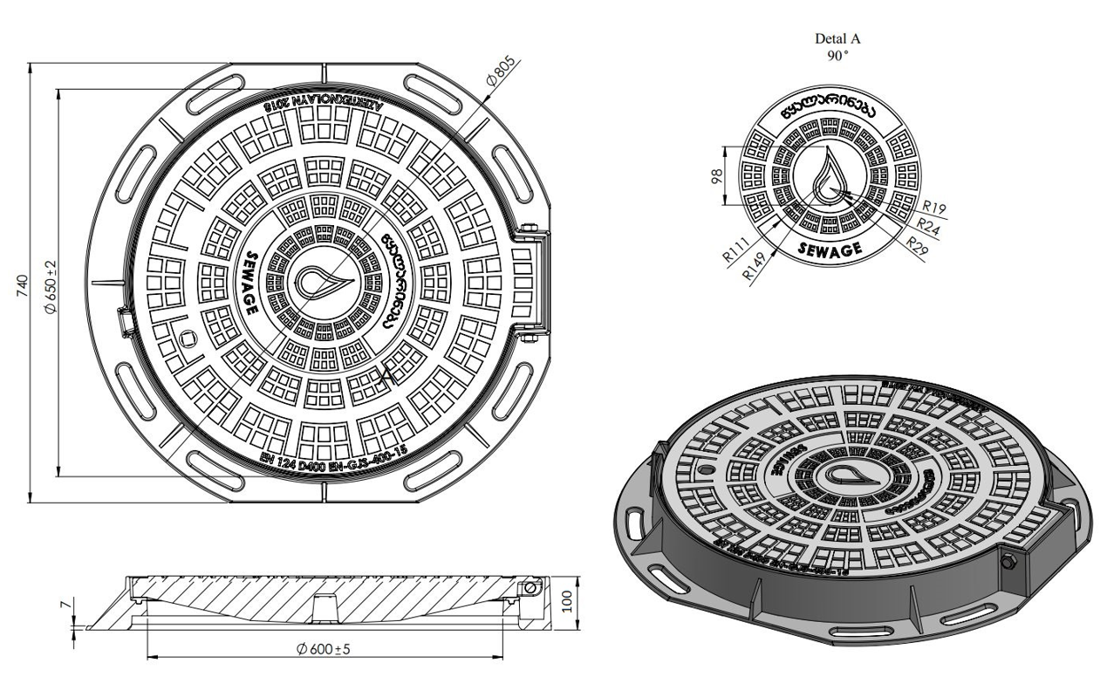
1.3 Estimation
The bidder must submit the estimates according to Annex N1 in Excel format.

1.4 Form and place of delivery of goods
Georgian Water and Power Ltd (GWP) Place of delivery:
Warehouse of "Georgian Water and Power" Ltd, Peikrebi Street N14

1.5 Payment terms
Payment will be made by consignment, with non-cash payment within 30 (thirty) calendar days after receiving the goods and signing of the relevant acceptance certificate and / or relevant documents

1.6 Data to be uploaded / submitted by the bidder in the electronic tender:
1. Price table (in accordance with Annex N1);
2. Extract from the Register of Entrepreneurs and Non-Entrepreneurial (Non-Commercial) Legal Entities, which must be issued after the announcement of this electronic tender;
3. Consent to these tender conditions, for which a signed tender application must be submitted;
4. List and pictures or drawings of similar constructions made during the last 2 years.
5. Information on the materials used Quality certificates issued by the relevant authorities.
6. Photo of the door frame-lid shutter;
7. Video material for closing the frame-lid of the pit is desirable.

1.7 Warranty conditions
1. The warranty period of the goods is defined as 10 (ten) years.

Note:
- All documents and / or information created by the bidder uploaded in the electronic tender must be signed by an authorized person (if necessary, a power of attorney must be uploaded);
- All documents and / or information created by the bidder must be confirmed by the electronic signature of the authorized person or the electronic stamp of the company.
- If the bidder is a foreign enterprise that is not registered in Georgia, bidder can send the bid via e-mail, which is indicated in the contact information of this tender documentation.
- Also, if some technical problem will arise, during bid submission on tender site, the bidder can send a proposal on the e-mail specified in the tender documents. We would like to state that the proposal must be submitted by e-mail no later than 18:00 on July 8th, 2024

1.8 Signing a contract
Within the framework of this e-tender, a single contract will be concluded in accordance with the draft contract and the tender proposal attached to this tender.

Contract performance guarantee - 1 year.
1.9 Other requirements
1.9.1 At the time of submission of the proposal, the bidder should not be:
• in the process of bankruptcy;
• In the process of liquidation;
• In a state of temporary suspension of activities.
1.9.2 Presentation of prices is allowed only in the national currency of Georgia (GEL). Prices should include all costs and taxes (including VAT) provided by this tender.
1.9.3 The bid submitted by the bidder must be valid for 30 (thirty) calendar days from the date of receipt of bids.
1.9.4 The Procurer (Georgian Water and Power LLC (GWP, JSC 203826002) reserves the right to set the deadline for the tender, change the terms of the tender, notify the tender participants in a timely manner, or terminate the tender at any stage.
The Procurer (Georgian Water and Power Ltd (GWP, ID 203826002)) will identify the winning supplier to the Tender Commission and notify all participating companies of the decision. The Purchaser (Georgian Water and Power Ltd (GWP, ID 203826002)) is not obliged to provide the participating company with a verbal or written explanation of any decision regarding the competition.
The Purchaser (Georgian Water and Power LLC (GWP, ID 203826002)) reserves the right to verify any information received from the Bidders, as well as to obtain information about the Bidder Company or its activities. If it is proved that the information provided by the bidder is not true or falsified, the bidder will be disqualified.
Please note that the Purchaser (Georgian Water and Power Ltd (GWP, ID 203826002) will not receive any oral inquiries for additional information, except by telephone.
Note: Any other information obtained by other means will not be official and does not give rise to any liability on the part of the Purchaser (Georgian Water and Power LLC (GWP, ID 203826002)).

1.10 Information for e-tender participants
1.10.1 Any questions during the tender process must be in writing and the online Q&A mode of tenders.ge portal must be used;
1.10.2 To participate in the electronic tender, the company must be registered on the website www.tenders.ge
1.10.3 Instructions for participation in the electronic tender on tenders.ge can be found in the attached file
I got acquainted
/ Signature of the authorized person of the participating company /

Contact information:
Procurement representative
Contact person: Magda Lomtatidze
Address: Georgia, Tbilisi, Mtatsminda district, Medea (Mzia) Jugheli street, №10
E-mail Email: mlomtatidze@gwp.ge
Tel: +995 322 931111; 595 22 66 94

Contact person: Irakli Khvadagadze
Address: Georgia, Tbilisi, Mtatsminda district, Medea (Mzia) Jugheli street, №10
E-mail Email: ikhvadagadze@gwp.ge
Tel: +995 322 931111 (1141); 599 505 067

