OVERHEAD CRANE 25 T

Tbilisi 2024
Content

1 introduction and project description 3
2 communications and submissions 3
3 Closing date 3
4 submissions 4
5 PRICING 4
6 Scope of delivery 5
7 Design Information 8
7.1 Site and Operation Conditions 8
7.2 Data Sheet and Grinding Building Drawing for Overhead Crane in Grinding Area 9
8 Work excluded 14

INTRODUCTION AND PROJECT DESCRIPTION

RMG is in the process of detailed engineering and construction of its Beqtaqari polymetallic concentrator and inviting interested bidders to submit technical and commercial proposals for overhead crane. The concentrator will be located in southern Georgia (Eastern Europe), approximately 50 km southwest from capital Tbilisi, near the town of Bolnisi. Site access will be via paved local roads. Refer to figure 1 for general site location

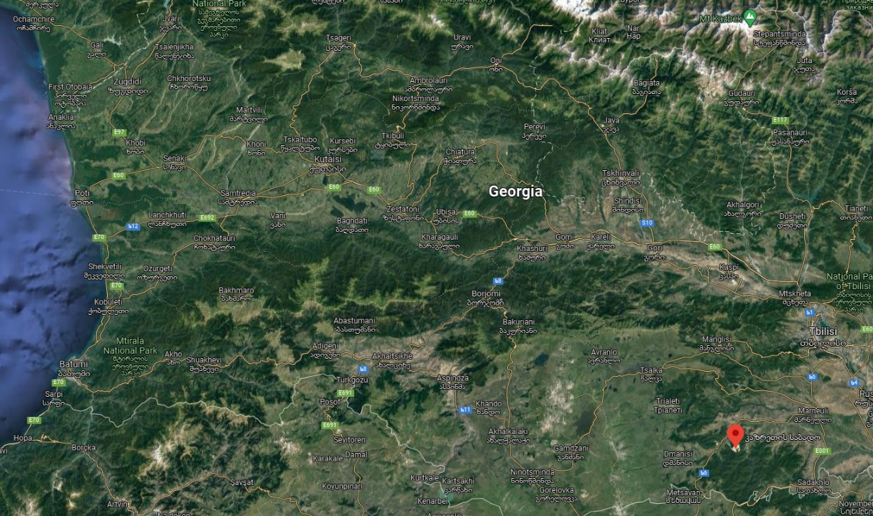
Auramine Beqtaqari
Site Location

Figure 1: RMG Auramine LLC, Concentrator site location

The present document covers and provides the minimum requirements and specifications needed for Overhead Crane requested by RMG project.

COMMUNICATIONS AND SUBMISSIONS

Complete, technical and commercial proposals as separate documents to be submitted in electronic format.

CLOSING DATE

SUBMISSIONS

The documents and all drawings, design, specifications and other data appended or related to it are the property RMG and are supplied only for the purpose of enabling each potential bidder to prepare and submit a proposal package. The information contained or referred to in the RFP documents or appended to it is not to be disclosed or released for any other use or purpose.

PRICING

A lump sum with fixed and firm prices, in USD ($) or Euros (€), without subjected price escalation and exclusive of local taxes must be furnished for all items included in chapter 6 – Scope of delivery. The commercial proposal should also provide the breakdown of prices by individual item quoted within the scope.

SCOPE OF DELIVERY

The scope will cover the provision of complete and functional overhead crane. The Scope of delivery shall include the equipment as per the list below:

Name | TAG Number | Quantity | Main lifting capacity/ t | Aux lifting capacity/ t | Amounts of hoists
Overhead Crane | 200-CN-001 | 1 | 25 | 5 | double hoist

Name | TAG Number | Digital weight scale | Operator Cabin  (See position in the drawing) | Location of the crane
Overhead Crane | 200-CN-001 | included for main hoist and aux hoist (optional) | Included | Grinding Building

Additional requirements and points of interest:
- The crane needs to be controllable via wireless remote control and from the included operator table.
- The weight measurement of the main hoists and auxiliary hoists (if any) should be readable from the wireless remote control and from a display inside the operator’s cabin.
- Walkways on the crane frame, which serve two purposes:
  - As emergency exit for the crane operator inside the operator cabin.
  - To allow access for maintenance of the crane.
- Two separate moving speeds for crane’s traversing speed, travelling speed, hoisting speed and auxiliary hoisting speed. Below are some indicative values. The supplier is welcome to give their own recommendation.

Grinding building - 200-CN-001
Traversing speed 32 m/min, 2-speed
Travelling speed 40 m/min, 2-speed
Hoisting speed 4/0.6 m/min, 2-speed
Hoisting Aux speed 16/2.7 m/min, 2-speed

- The vendor should give a recommendation for the crane speed of the grinding area (200-CN-001), which will be used to install a fully assembled grinding mill of 20 tons.
- Both hoists of the crane of the grinding area (200-CN-001) require a power connection to connect an electromagnetic ball lifter. The auxiliary hoist is intended to be used for refilling the mill charge with the ball lifter. The main hoist is intended to act as a back-up for this task in case the auxiliary hoist is malfunctioning.

- If the vendor is supplying electromagnetic ball lifters, one piece can be offered as an optional item with the proposal.

- The table below shall provide a short summary of the intended use for the overhead crane:

Grinding building - 200-CN-001
Installation and maintenance of equipment (e.g. Grinding Mills)
Feeding of grinding media into the grinding mills (One SAG Mill, Two Ball Mills and one Stirred Media Mill). Refilling is to be expected to happen two to five times a day per mill.
Lifting a liner handler in place before the SAG Mill
Everyday maintenance issues

Complete overhead crane datasheet will consist of but not limited with:
- Overhead crane dimensioned for the given data
- Electric motor
- Mechanical drive system
- Overload protection
- Bridge and trolley travelling motors protection
- Electrical control panel including fused disconnect switch
- Radio remote control and pendant control
- Normal lifting speed and slow speed for equipment installation (2 lifting speed)
- All necessary instrumentation
- Safety Devices and Guards
- Weight of operation cabin
- Any other component that the vendor might find suitable for the proper operation of the equipment

Electrical and instrumentation specifications:
- Standards: IEC Standards.
- Duty type: Continuous.
- Operating Voltage: 400 V
- Frequency: 50hz
- Protection: shall be equipped with protection of suitable IP rating.

Additionally, the following items are to be included in the technical proposal for all bidded equipment:

- Detailed technical specification: Dimensions, performance, electrical and physical data
- Type and list of equipment
- Standard drawing of the proposed system/equipment (.PDF and .DWG)
- Standard schematic showing the main equipment and all their auxiliary components which are included (.PDF and .DWG)
- 3D General Arrangement models if available
- Installation drawings and installation, operation, and maintenance manuals (language Russian if available and/or English)
- Mechanical guarantee
- Trial Assembly
- Reports of inspection and testing
- Special tools for field erection and maintenance
- Equipment tests and registers (X-rays, magnetic particles, others)
- Any other component that the vendor might find suitable for the proper operation of the equipment
- Vendor drawing and Data Requirement (VDDR) and schedule.
- Other options if any

The commercial proposal must be detailed and include the following information:
- Price breakdown
- Payment milestone
- Commissioning and start-up spares.
- Spare parts for 2 years of operation
- Delivery term FCA
- Delivery date
- Warranty
- Shipping weight and dimensions
- Validity of quotation
- General Terms and Conditions
- Site supervision services (daily rate + rate during travel (if charged any). RMG will provide accommodation, meal and transfers. The supervision services should also include number anticipated days and total budget.
- List of relevant references

DESIGN INFORMATION
7.1 Site and Operation Conditions
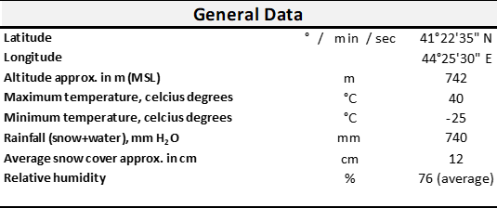

Seismicity Parameters
Annual Exceedance Probability (AEP) | MSK-64 | PGA (g)
1:1,000 year (5% in 50 years) | 8 | 0.20 - 0.30
1:2,500 year (2% in 50 years) | 9 | 0.20 - 0.30
1:5,000 year (1% in 50 years) | 9 | 0.30 - 0.40

Maximum seismicity parameters from the table – 0.4 g.

7.2 Data Sheet and Grinding Building Drawing for Overhead Crane in Grinding Area

Equipment Description
Equipment name | Grinding area overhead crane
TAG Number | 200-CN-001
Equipment type | Overhead crane
Model | To be determined by supplier
Process Data
Crane requested for | Grinding building
Heaviest part to lift | 19 tons
Requested main lifting capacity | 25 tons
Requested Aux. lifting capacity | 5 tons
Building size L x W x H | 42000 mm x 18000 mm x 22180 mm
Crane area dimensions L x W x H | 41400 mm x 16900 mm x 19180 mm
Crane travel | 41400 mm
Crane span | 16900 mm
Operating conditions
Plant elevation | 750 m above sea
Facility temperature (indoor) | 20 °C
Area's operation time | 24 h per day / 7 days per week / 52 weeks per year
Area's availability | 90% daily target
Electrical power supply for crane | 400 V / 3 Ph / 50 Hz

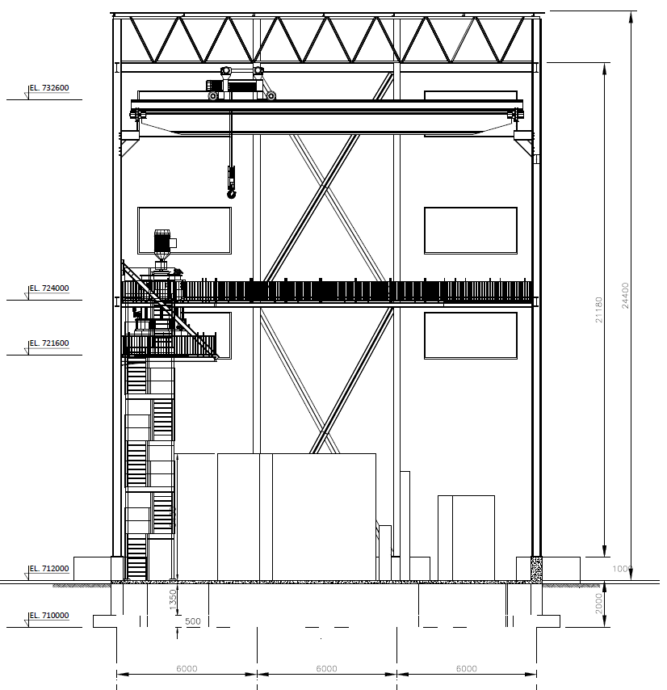

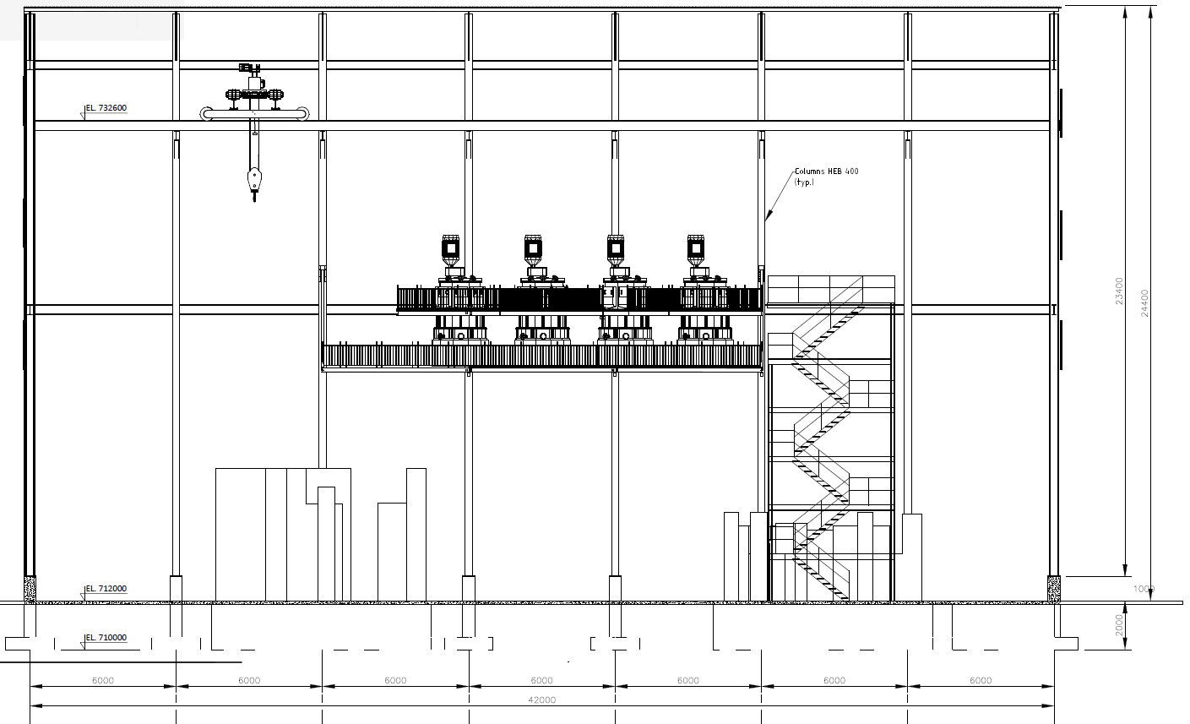
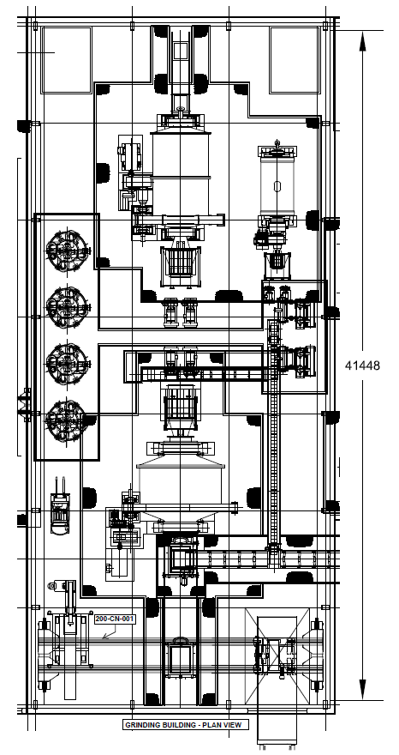
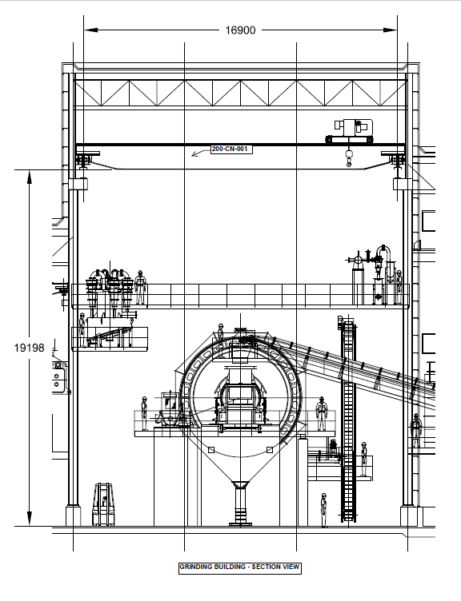

Layout with the hooking point position of the closer equipment to the building columns in grinding and flotation area. (See attachment drawing in .dwg format)

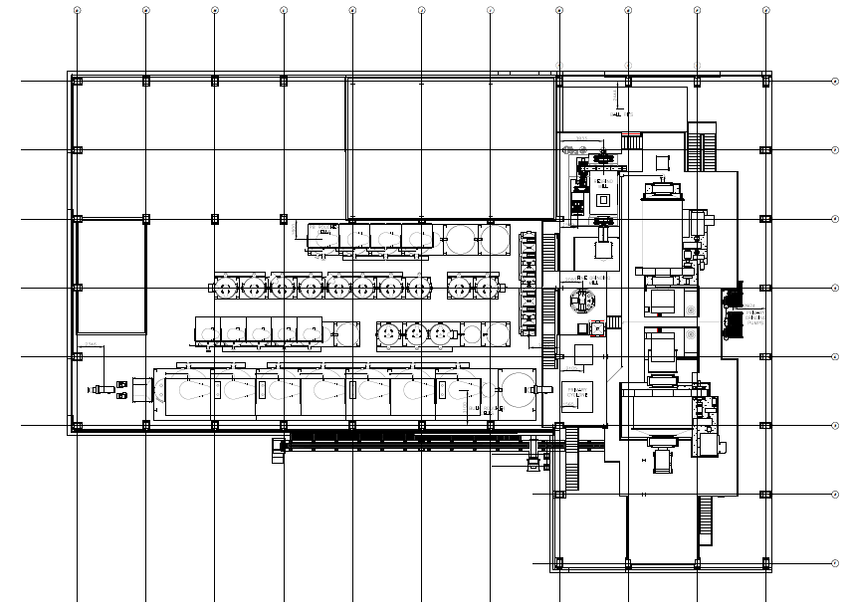

WORK EXCLUDED

The following items of work are specifically excluded from the Contractor’s Scope of Supply:

- All civil and building works
- Provision of electrical power, water and compressed air

Should the Contractor wish to make any further exclusions this should be highlighted clearly in the Contractor’s proposal. Agreement to exclude any further items may be dependent on the. Contractor’s timely provision of design information required to allow the Purchaser to procure them.

